# PRACTICAL FILE

# OF

## “Practical -1 ‘C’ Prog. Lab”

**(BCA 171)**

submitted in the partial fulfillment of the requirement for the

award of degree of

#### **BACHELOR**

**OF**

#### Description: C:\Users\Administrator\Desktop\0.jpg**COMPUTER APPLICATIONS**

**SUBMITTED BY:**

**VANSHIKA NEGI**

**Enrolment Number: 05217002021**

**Semester – 1**

**Shift – 1st**

**Batch: 2021-2022**

**SUBMITTED TO:**

**MR. AJAY DUREJA**

**ASSISTANT PROFESSOR**

**DEPARTMENT OF COMPUTER APPLICATIONS**

**INDEX**

|  |  |  |  |
| --- | --- | --- | --- |
| **S.NO.** | **PRACTICAL NAME** | **PAGE** | **SIGNATURE** |
| **1** | Write a program to perform addition of two numbers. |  |  |
| **2** | Calculate Simple Interest for a set of values representing principal, number of years and rate of interest. |  |  |
| **3** | Ramesh’s basic salary is input through the keyboard his dearness allowance is 40% of basic salary and house rent allowance is 20% of basic salary. Write a program to find his gross salary. |  |  |
| **4** | The length and breadth of rectangle and radius of a circle are input through the keyboard. Write a program to calculate the area and perimeter of a rectangle and the area and circumference of a circle. |  |  |
| **5** | Temperature of a city in Fahrenheit degree is input through the keyboard. Write a program to convert this temperature into Celsius degree. |  |  |
| **6** | Write a program to find the greatest number between 3 numbers given by the user. |  |  |
| **7** | If quantity purchased is more than 1000 then the discount of 10% is offered. If price and quantity input through the keyboard, Write a program to calculate total expenditure |  |  |
| **8** | Write a program to swap two numbers using a third variable. |  |  |
| **9** | Two number input through the keyboard into 2 location. Write a program to interchange the contents of C and D. |  |  |
| **10** | Write a program to input 5 digit number from keyboard and print its sum of a digits. |  |  |
| **11** | Write a program to input through the keyboard and print the number in reverse order. |  |  |
| **12** | If an employee basic salary is less than 1500 then House rent allowance will be 10% and Dearness allowance 90% of basic salary, if his salary is either equal to or above 1500 then house rent allowance will be Rs.500 and dearness allowance 98% of basic salary. If the salary is input through the keyboard then write a program to find his gross salary. |  |  |
| **13** | Write a program to check if a given no. is odd or even. |  |  |
| **14** | Write a program to check if a given number is prime or not. |  |  |
| **15** | Write a program to input a number and print its table. |  |  |
| **16** | Write a program to check if a given no. is odd or even with using turnary operator. |  |  |
| **17** | Write a program to print the table of any number using while loop. |  |  |
| **18** | Write a program to find the average of six subjects and display the results as follows. |  |  |
| **19** | Write a program to find a factorial value of any number enter through the keyboard. |  |  |
| **20** | Write a program to print all Armstrong no. between 1 and 500. |  |  |
| **21** | Two number are entered through the keyboard write a program to find value of one no. raised to another no. |  |  |
| **22** | Write a program to print all the odd and even numbers from 1 to 100. |  |  |
| **23** | Write a program to calculate the salary of three persons. The given data basic salary is input through the keyboard. House rent allowance and dearness allowance are 90% and 10% of basic salary. Calculate gross salary. |  |  |
| **24** | Write a program to find if the number is factorial, Prime or not, odd or even and exit using switch case. |  |  |
| **25** | Write a menu driven program to construct a calculator for following arithmetic operations: Addition, Subtraction, Multiplication, division, average and percentage |  |  |
| **26** | The distance between two cities in km is input through the keyboard write a program to convert and print the distance in meter, feet, inches and centimeters. |  |  |
| **27** | Write a menu driven program to perform the following operations:  (1) Print Armstrong numbers up to N,  (2) Display prime numbers between 1 to N  (3) Reverse of an integer |  |  |
| **28** | Write a program in C to swap two numbers using Call by value. |  |  |
| **29** | Write a program in C to swap two numbers using Call by reference. |  |  |
| **30** | Write a program in c to calculate area and perimeter of a circle using call by reference. |  |  |
| **31** | Write a program to add, subtract, multiply and divide two numbers using pointers. |  |  |
| **32** | Write a program to input marks of 50 students using an array and display the average marks of the class. |  |  |
| **33** | Write a program to search for a number entered by the user in a given variable. |  |  |
| **34** | Write a program in C to pass array element to a function by call by value. |  |  |
| **35** | Write a program in C to pass array element to a function by call by reference. |  |  |
| **36** | Write a program in C to print the following pattern.  *  **  ***  ****  ***** |  |  |
| **37** | Write a program in C to print the inverted half pyramid of *. |  |  |
| **38** | Write a program in C to print the half pyramid of numbers  1  1 2  1 2 3  1 2 3 4 |  |  |
| **39** | Write a program using pointers to compute the sum of all elements stored in the array. |  |  |
| **40** | Write a program in C to sort the elements of an array using pointers. |  |  |
| **41** | Write a program for the use of malloc and free function |  |  |
| **42** | Write a program to show the concept of dynamic memory allocation for an array |  |  |
| **43** | Write a program to perform matrix addition, multiplication and transpose |  |  |
| **44** | Write a program to check if string is a palindrome or not ,using predefined function strcmp. |  |  |
| **45** | Write a program to check if string is a palindrome or not ,without using predefined function. |  |  |
| **46** | Write a menu driven program to implement following operations:  (i) Calculate length of string  (ii) Concatenate at the end of a given string  (iii) Copy one string to another  (iv) Compare contents of two strings  (v) Copy nth character string to another. |  |  |
| **47** | Write a program to find factorial using recursion |  |  |
| **48** | Write a program to convert hexadecimal into binary number |  |  |
| **49** | Write a program to create a structure for students containing the following data members :-   1. Name of the student 2. Roll number of the student 3. Marks of the student   Input data of students & display the details of the employee i’d given by the user. |  |  |
| **50** | Write a program to pass address of a struct variable to a user defined function and display the content. |  |  |
| **51** | Write a program to make use of array with array in following way:   1. Use array as a structure data member. 2. Create array of structure variable. |  |  |
| **52** | Write a program to illustrate difference between structure and array. |  |  |
| **53** | Write a program in c to show the use of concept of enumeration. |  |  |
| **54** | Write a program to read the data from the keyboard, write into the file named ‘input’ and again read the same data from the ‘input’ file and display it on the screen. |  |  |
| **55** | Write a program to open pre-existing file and add the information at the end of the file. |  |  |
| **56** | Write a program to show the use of W+ mode in file handling. |  |  |
| **57** | Write a program to open a file for read or write operation in binary mode read and write a new information in the file. |  |  |
| **58** | Write a program to open a text file and write some text using fprintf(). |  |  |
| **59** | Write a program to create a file “data” which contains a series of integer numbers and then write all the odd numbers to a file called “odd file” and all the even number in “even file”. |  |  |
| **60** | Write a program to read the text file containing some sentence use fseek() and read the text after skippping n characters form beginning of the file. |  |  |

**Program 1:** **Two numbers are input through the keyboard. Calculate their sum.**

**Source code:**

#include<stdio.h>

#include<conio.h>

void main()

{

int a,b;

printf(“\nEnter two numbers:”);

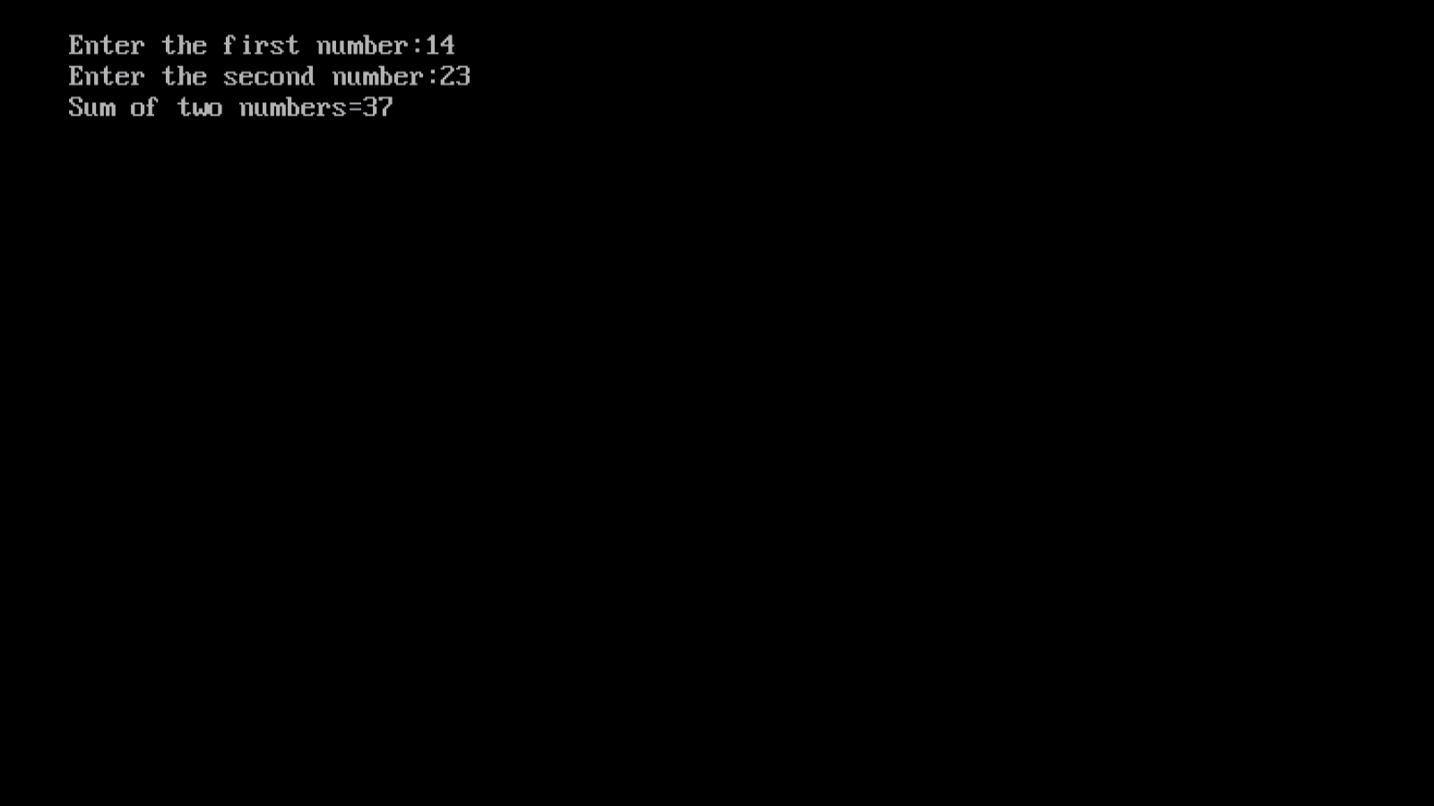scanf(“%d%d”,&a,&b);

printf(“\nAddition=”%d”,a+b);

getch()

}

**Program 2:** **To calculate simple interest for a set of values representing principal, number of years and rate of interest.**

**Source code:**

#include <stdio.h>

#include <conio.h>

void main()

{

float p,r,t,SI;

printf("Enter Principle:");

scanf("%f",&p);

printf("Enter Rate:");

scanf("%f",&r);

printf("Enter Time:");

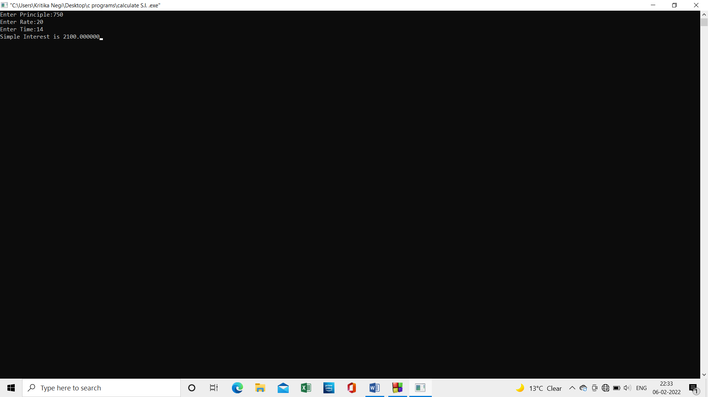 scanf("%f",&t);

SI=(p*r*t)/100;

printf("Simple Interest is %f",SI);

getch(); }

**Program 3:** **Ramesh’s basic salary is input through the keyboard, his dearness allowance is 40% of basic salary and house rent allowance is 20% of basic salary. Write a program to calculate gross salary.**

**Source code:**

#include<stdio.h>

#include<conio.h>

void main()

{

int BS;

float DA,HRA,GS;

printf("Enter Ramesh's basic salary:");

scanf("%d",&BS);

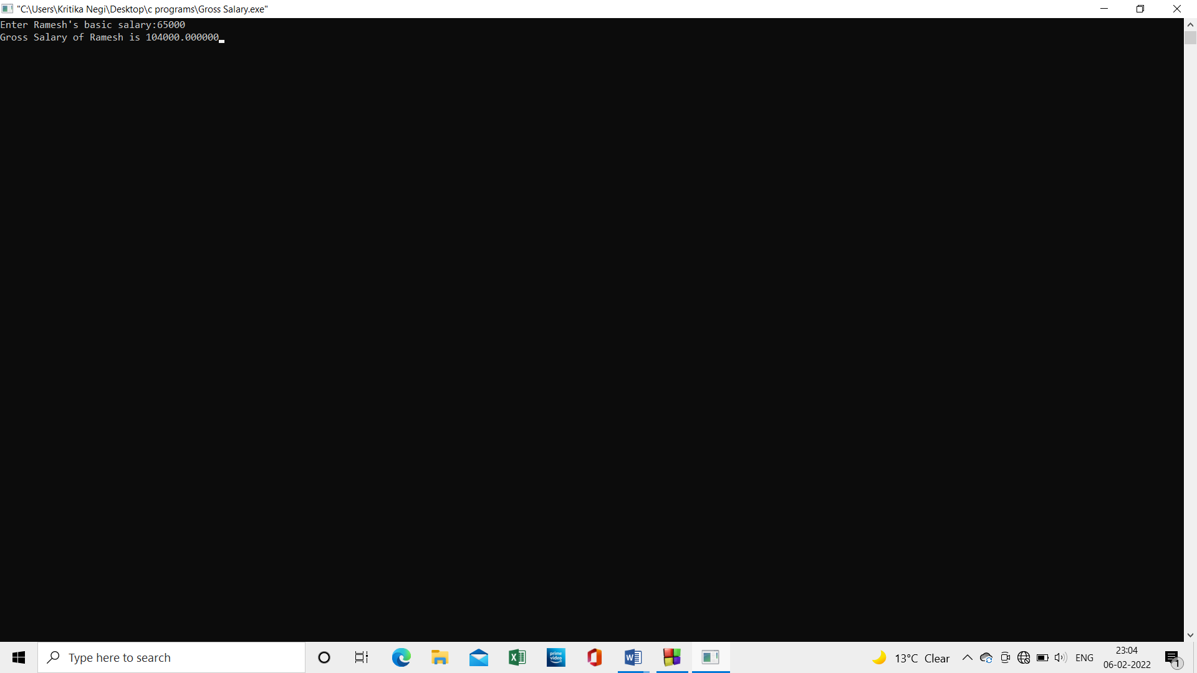 DA=(40*BS)/100;

HRA=(20*BS)/100;

GS=BS+DA+HRA;

printf("Gross Salary of Ramesh is %f",GS);

getch(); }

**Program 4: The length and breadth of a rectangle and radius of a circle are input through the keyboard. Write a program to calculate the area and perimeter of rectangle and circumference of the circle.**

**Source code:**

#include<stdio.h>

int main()

{

int l,b,r,area,per;

float circum;

printf("Enter length for rectangle:");

scanf("%d",&l);

printf("\tEnter breadth for rectangle:");

scanf("%d",&b);

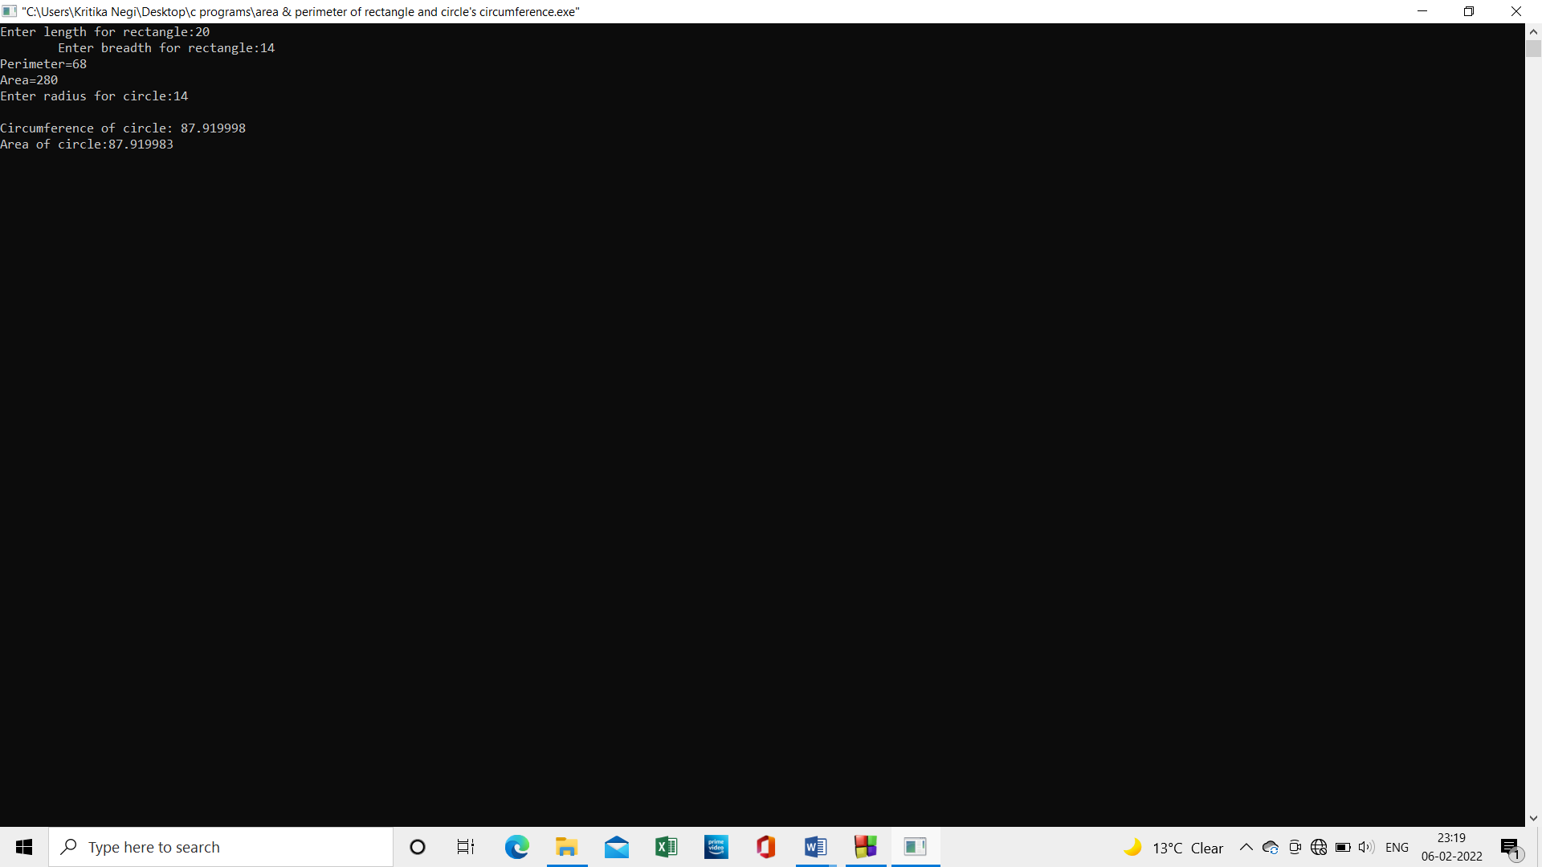 per=2*(l+b);

area=l*b;

printf("Perimeter=%d",per);

printf("\nArea=%d",area);

printf("\nEnter radius for circle:");

scanf("%d",&r);

circum=2*3.14*r;

area=3.14*r*r;

printf("\nCircumference of circle: %f",circum);

printf("\nArea of circle:%f",area);

getch(); }

**Program 5:** **Temperature of a city in Fahrenheit degree is input through the keyboard. Write a program to convert this temperature into celcius degree.**

**Source code:**

#include<stdio.h>

int main()

{

    float far ,celsius ,cel ;

    printf("Enter your Celsius = ");

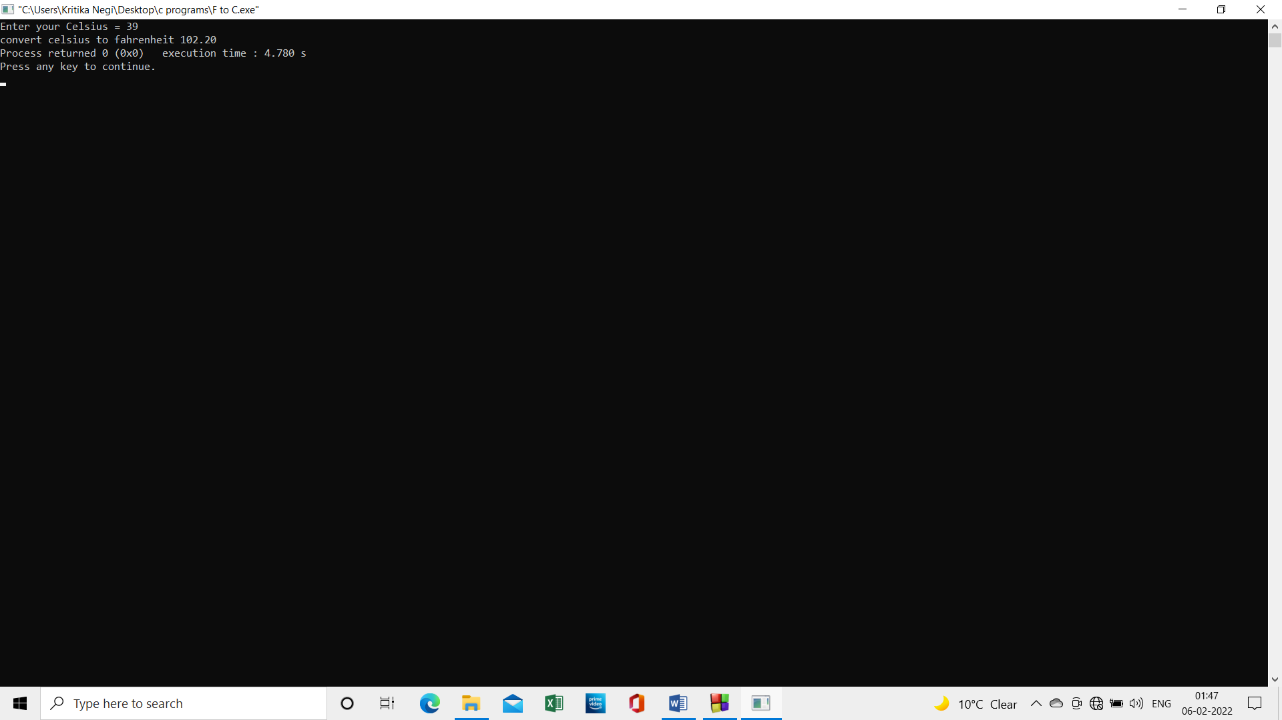    scanf("%f", &celsius);

    far= (celsius * 1.8) + 32 ;

    printf("convert celsius to fahrenheit %0.2f " ,far)

    return 0; }

**Program 6:** **The distance between two cities in kilometres is input through the keyboard. Write a program to convert and print the distance in metres, centimetres, feet and inches.**

**Source code:**

#include<stdio.h>

int main()

{

    float km ,m ,cm ,feet ,inches;

    printf("enter distance b/w two cities(in km) = ");

    scanf("%f", &km);

    m = 1000*km;

    cm = 1000*100*km;

    feet = 3280.84*km;

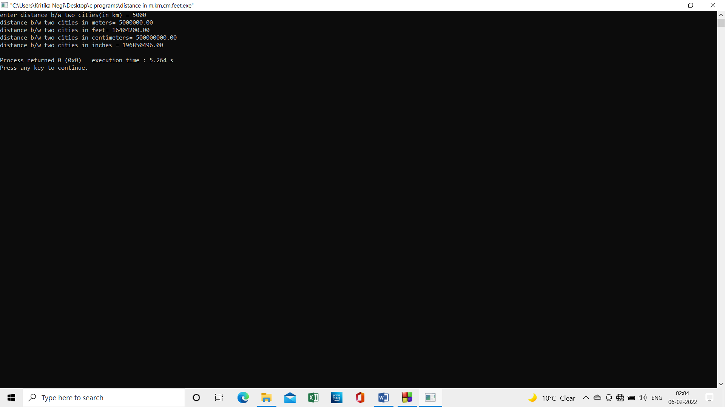    inches = 39370.1*km;

    printf("distance b/w two cities in meters= %.2f\n" ,m);

    printf("distance b/w two cities in feet= %.2f\n" ,feet);

    printf("distance b/w two cities in centimeters= %.2f\n" ,cm);

    printf("distance b/w two cities in inches = %.2f\n" ,inches);

    return 0;

} }

**Project 6: Write a program to find the greatest number among the three numbers given by the user.**

**Source code:**

#include <stdio.h>

#include <conio.h>

int main()

{

int a,b,c,grt;

printf("\nEnter 3 numbers:");

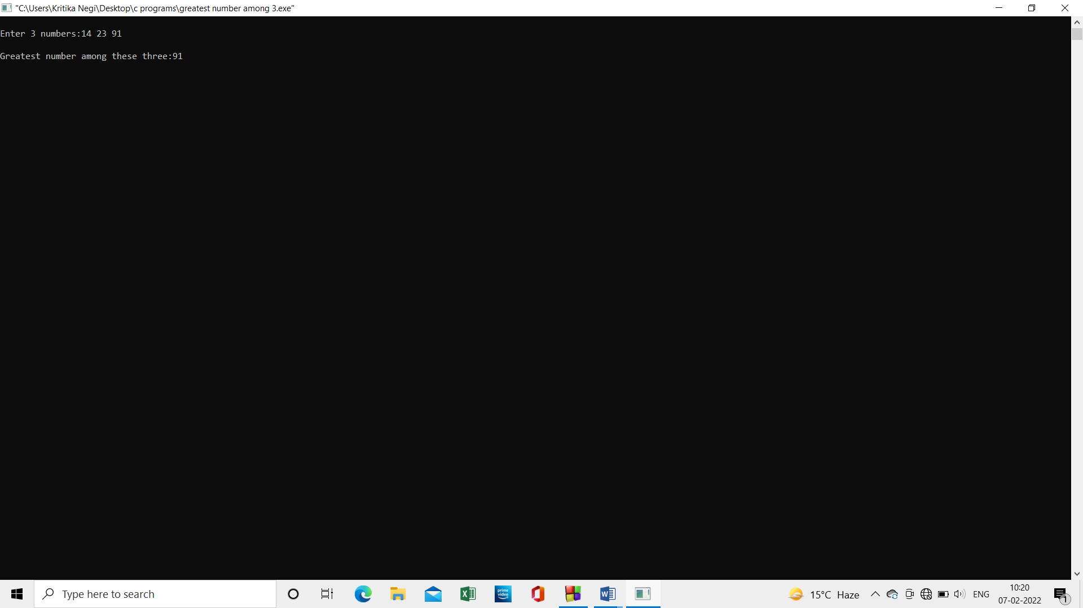scanf("%d%d%d",&a,&b,&c);

grt=(a>b&&a>c)?a:(b>a&&b>c)?b:c;

printf("\nGreatest number among these three:%d",grt);

getch();

return 0; }

**Program 7: While purchasing certain items a discount of 10% is offered, if quantity purchased is more than 1000. If quantity and price per item are input through the keyboard, write a program to calculate the total expense.**

**Source code:**

#include <stdio.h>

#include <conio.h>

int main()

{

int price,quant;

float totalexpenses;

printf("\nEnter quantity of products purchased:");

scanf("%d",&quant);

printf("\nEnter price of each item:");

scanf("%d",&price);

if (quant<=1000)

{

totalexpenses=price*quant;

totalexpenses= totalexpenses-(totalexpenses*0.1);

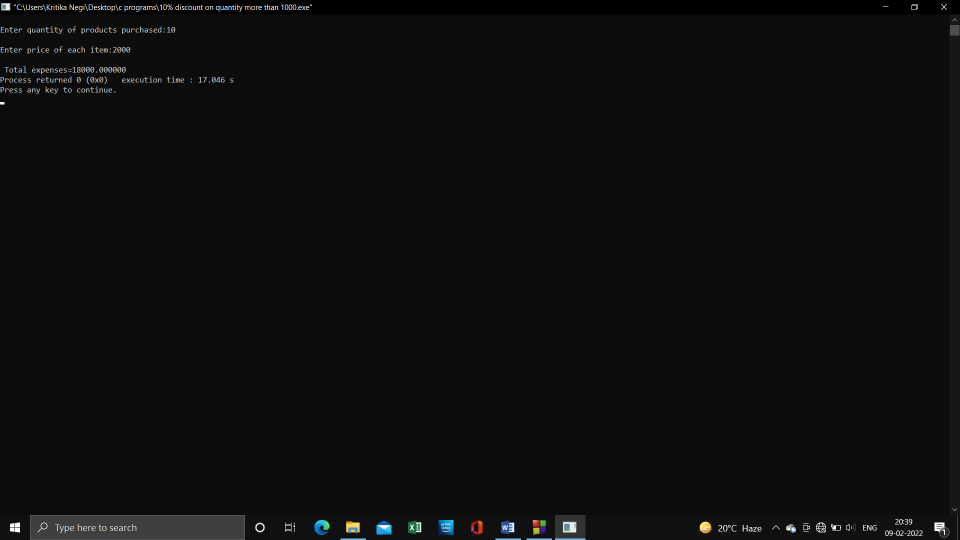 }

else

totalexpenses=price*quant;

printf("\n Total expenses=%f",totalexpenses);

return 0;

getch();}

**Program 8: Write a program to swap two numbers using a third variable.**

**Source code:**

#include <stdio.h>

int main()

{

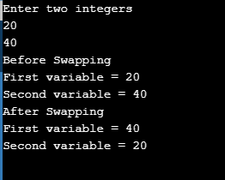int var1, var2, temp;

printf("Enter two integersn");

scanf("%d%d", &var1, &var2);

printf("Before SwappingnFirst variable = %dnSecond variable = %dn", var1, var2);

temp = var1;

var1 = var2;

var2 = temp;

printf("After SwappingnFirst variable = %dnSecond variable = %dn", var1, var2);

return 0;

}

**Program 9: Two numbers are input through keyboard in 2 locations c & d, Write a program to interchange the contents of c & d.**

**Source Code:**

#include<stdio.h>

int main(){

    int c ,d, temp;

    printf(" we are do swapping of a given number \n");

    printf("Enter first is c num = ");

    scanf("%d" ,&c);

    printf("Enter second is d num = ");

    scanf("%d" ,&d);

      temp=c;

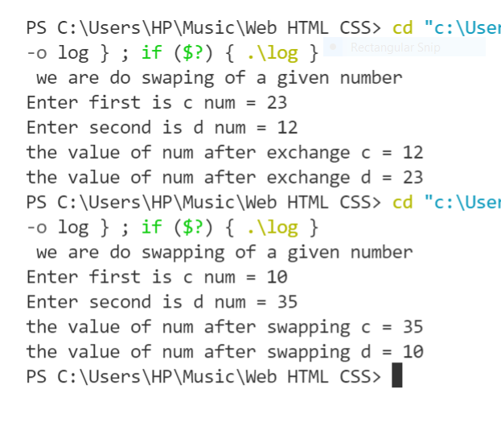      c=d;

      d=temp;

    printf("the value of num after swapping c = %d \n" ,c);

    printf("the value of num after swapping d = %d \n" ,d);

    return 0;

}

**Program 10: If a five digit number is input through keyboard, write a program to calculate the sum of its digits.**

**Source Code:**

#include <stdio.h>

int main()

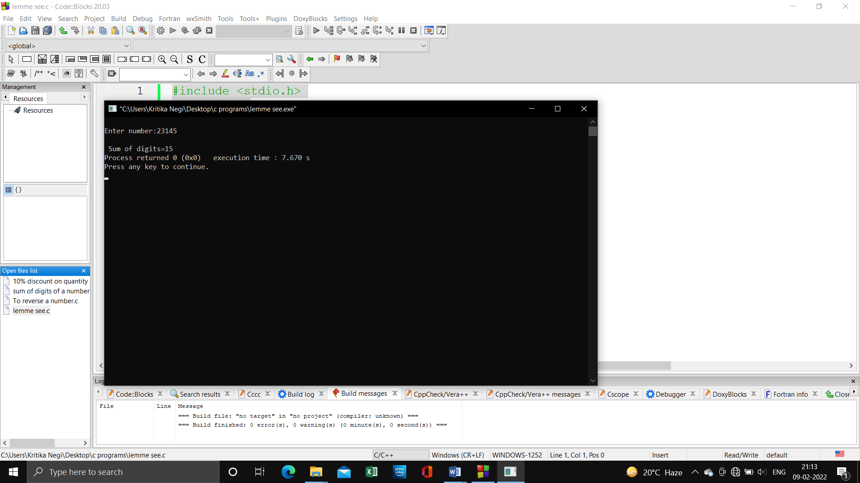{

int i,sum=0,n;

printf("\nEnter number:");

scanf("%d",&i);

while(i>0)

{

n=i%10;

sum=sum+n;

i=i/10;

}

printf("\n Sum of digits=%d",sum);

return 0; }

**Program 11: A five digit number is input through the keyboard, write a program to reverse the number.**

**Source Code:**

#include <stdio.h>

#include <conio.h>

int main()

{

int i,rev=0;

printf("Enter number to find reverse:"); //285

scanf("%d",&i);

while(i>0) //

{

rev=(rev*10)+i%10; //0+5=5;

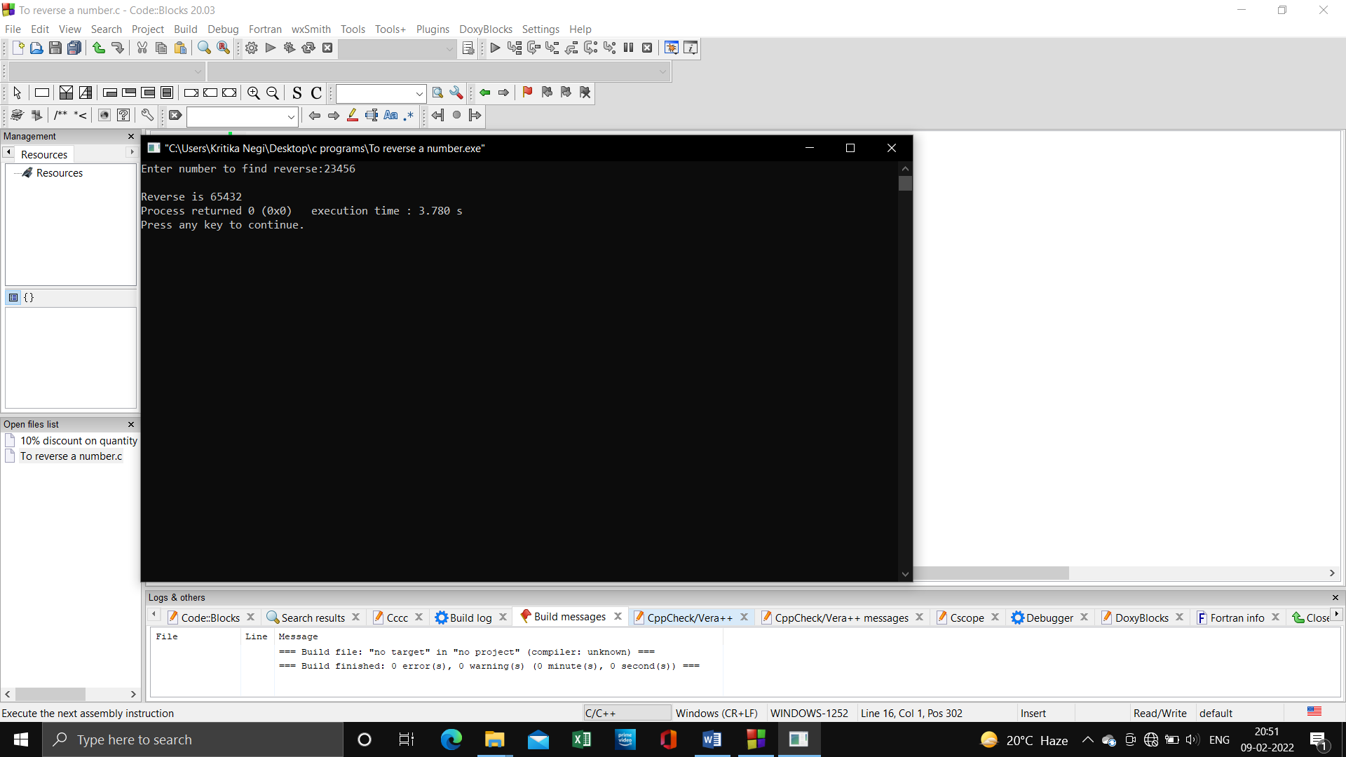 i=i/10; // 285/10=28

}

printf("\nReverse is %d",rev);

return 0;

}

**Program 12: If an employee basic salary is less than rupees 1500 then HRA will be 10% of basic salary and Dearness Allowance will be 90% of basic salary. If his salary is either equal or above 1500 then HRA will be 500 and Dearness Allowance will be 98% of basic salary. If employee salary is input through keyboard, write a program to find his gross salary.**

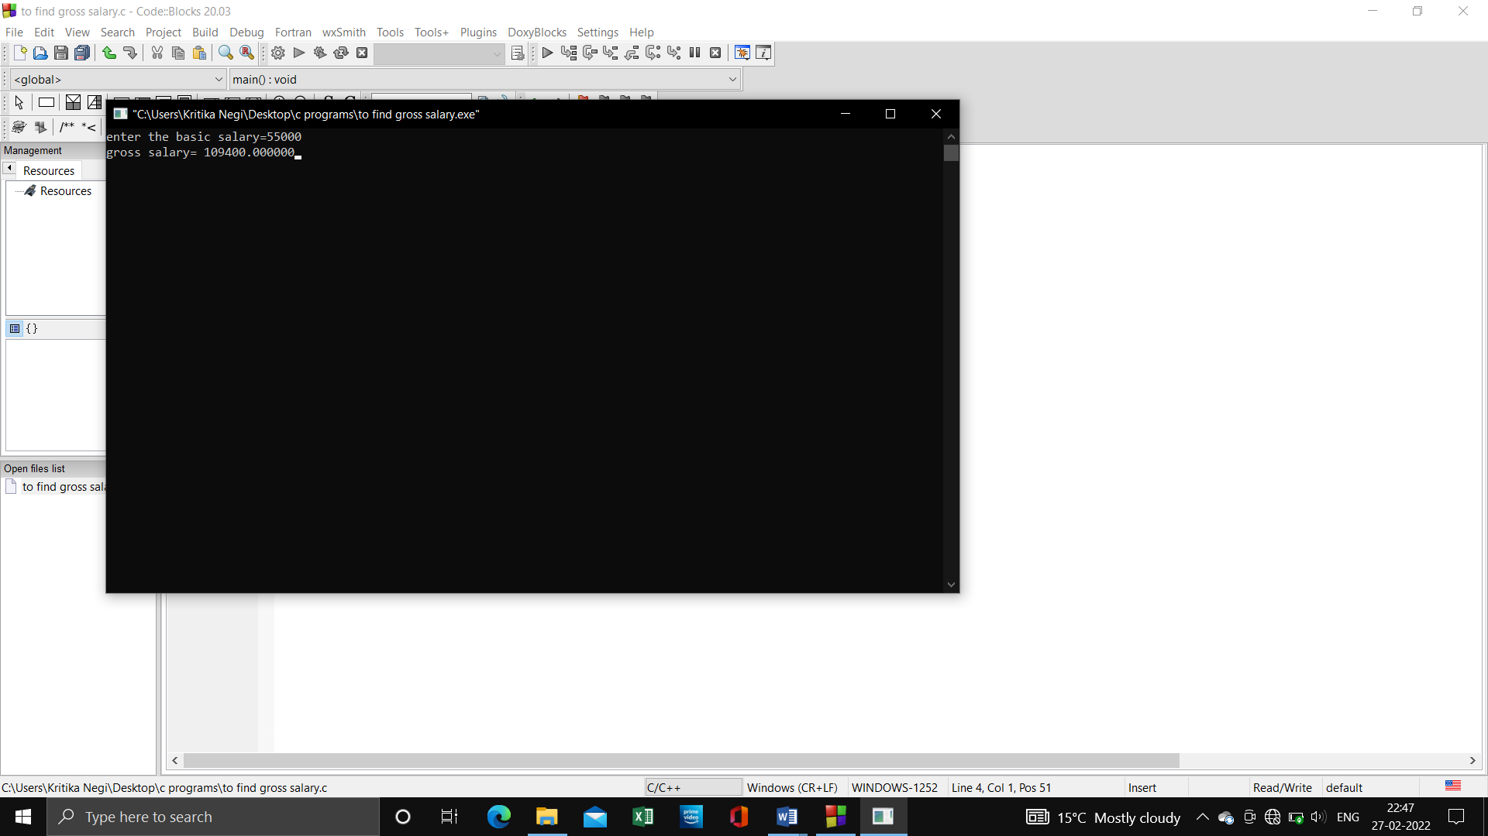**Source Code:**

#include<stdio.h>

#include<conio.h>

void main()

{

float bs,hra,da,gs;

printf("enter the basic salary=");

scanf("%f",&bs);

if(bs<1500){

hra=(bs*10)/100;

da=(bs*90)/100;

gs=bs+hra+da;

printf("gross salary= %f",gs);}

else{

hra=500;

da=(bs*98)/100;

gs=bs+hra+da;

printf("gross salary= %f",gs); }

getch();

}

**Program 13: Write a program to check if a given number is even or odd.**

**Source Code:**

#include <stdio.h>

int main()

{

int a;

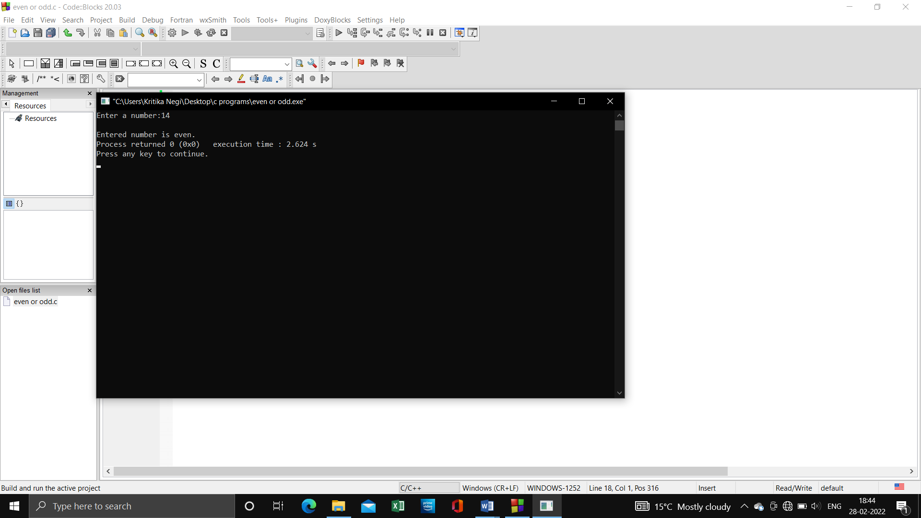 printf("Enter a number:");

scanf("%d",&a);

if (a%2==0)

goto even;

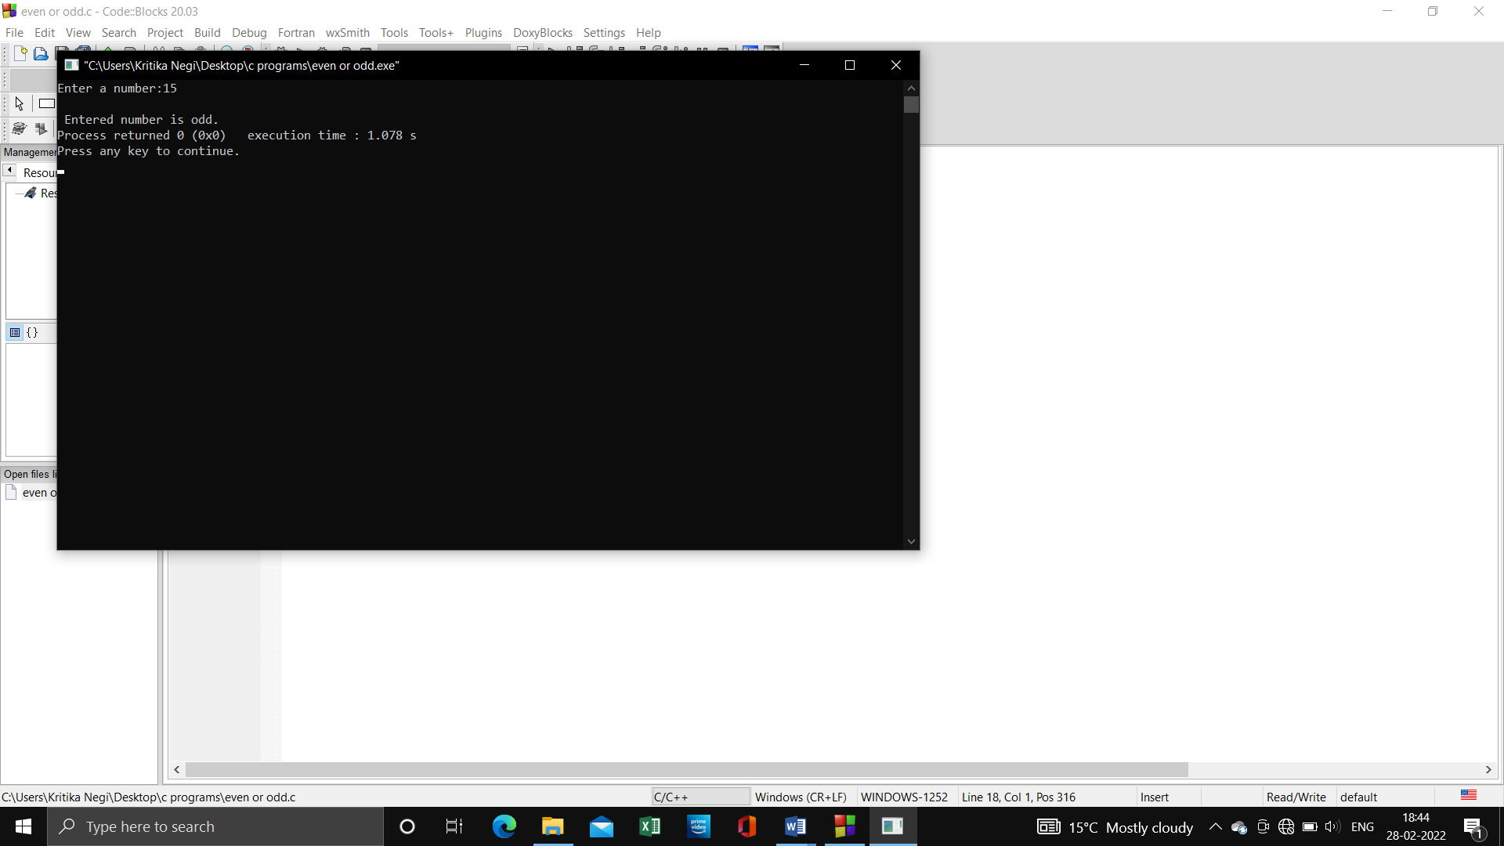 else

goto odd;

even:

printf("\nEntered number is even.");

return 0;

odd:

printf("\n Entered number is odd.");

return 0;

}

**Program 14: To check if a given number is prime or not.**

**Source Code:**

#include<stdio.h>

#include<conio.h>

void main(){

int num,i;

printf("enter a number : ");

scanf("%d",&num);

i=2;

while(i<num==1)

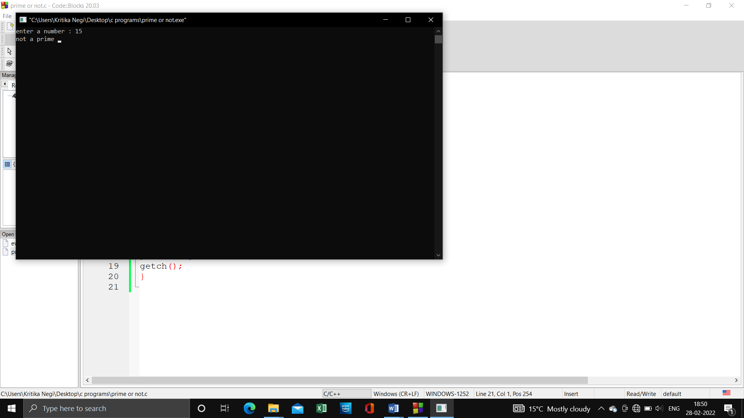{

if(num%i==0)

{

printf("not a prime ");

break;

}

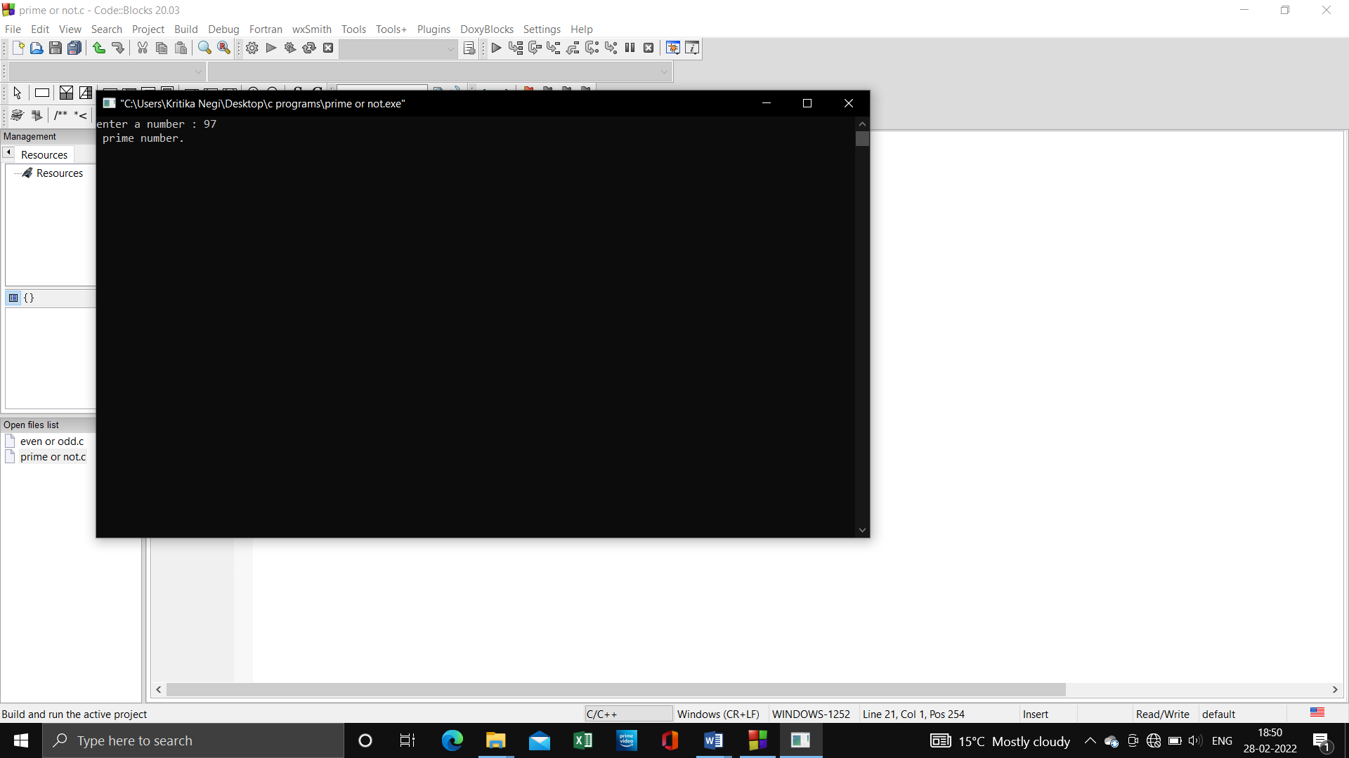i++;

}

if (i==num)

printf(" prime number.");

getch();

}

**Program 15: To input a number and print its table.**

**Source Code:**

#include<stdio.h>

int main()

{

int n,i=1;

printf("\nEnter the number you want table of:");

scanf("%d",&n);

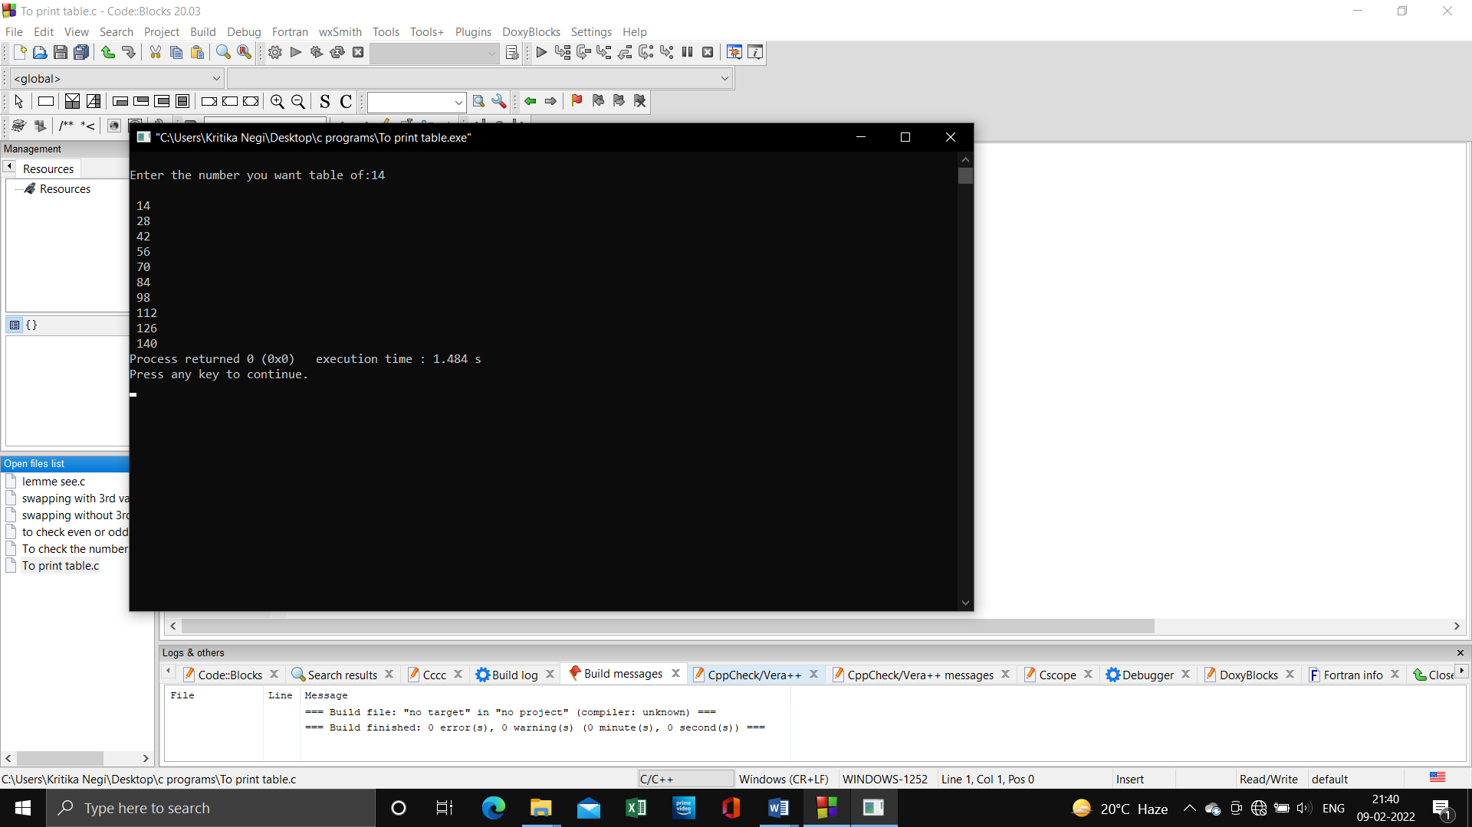 while(i<=10)

{

printf("\n %d",n*i);

i++;

}

return 0;

}

**Program 16: To check whether the given number is even or odd using ternary operator.**

**Source Code:**

#include<stdio.h>

#include<conio.h>

void main()

{

int num;

printf("enter a number: ");

scanf("%d",&num);

(num%2==0)?printf("number is even"):printf("number is odd");

getch();

}

**Program 17: To print the table of any number using while loop.**

**Source Code:**

#include<stdio.h>

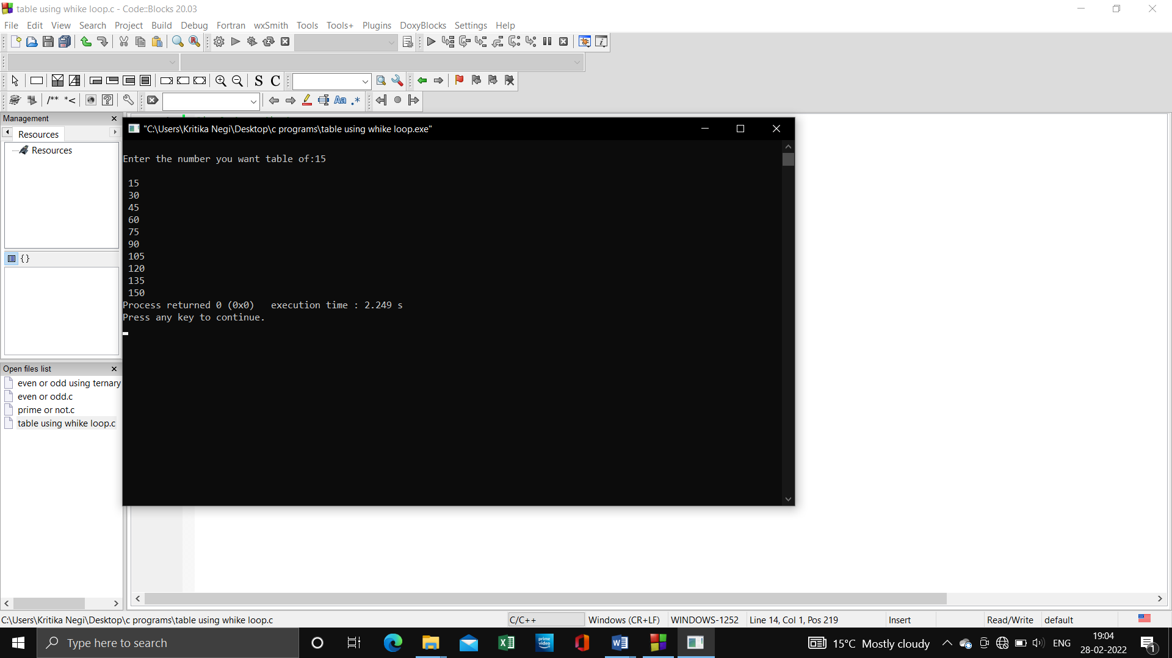int main()

{

int n,i=1;

printf("\nEnter the number you want table of:");

scanf("%d",&n);

while(i<=10)

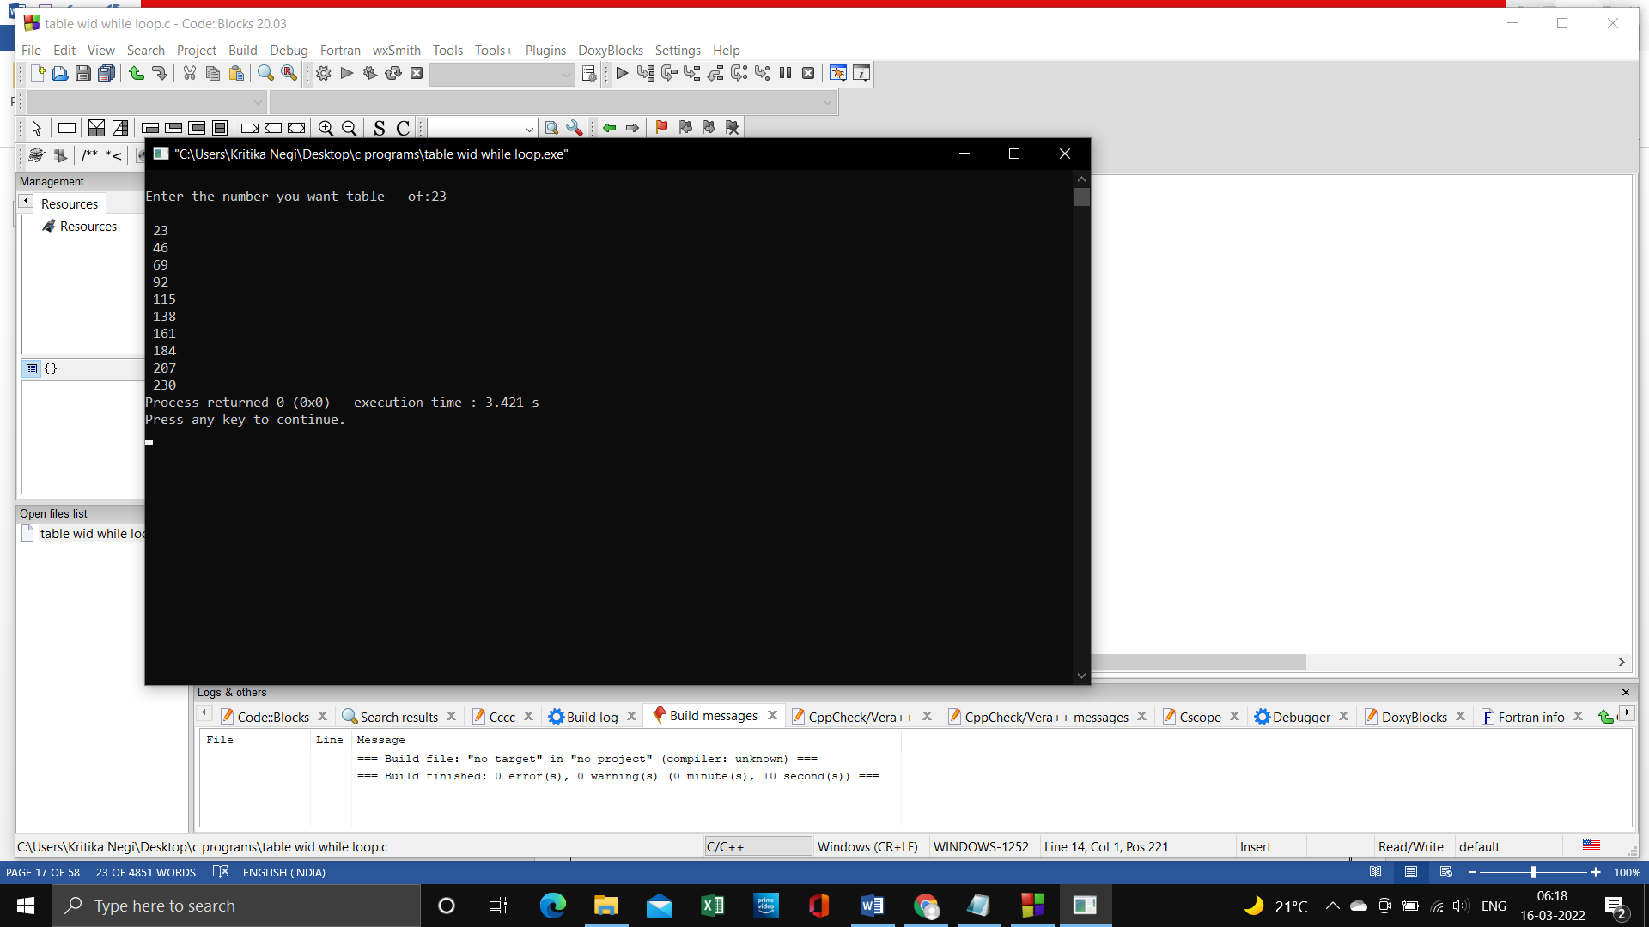 {

printf("\n %d",n*i);

i++;

}

return 0;

}

**Program 18: To find the average of 6 subjects and display the result.**

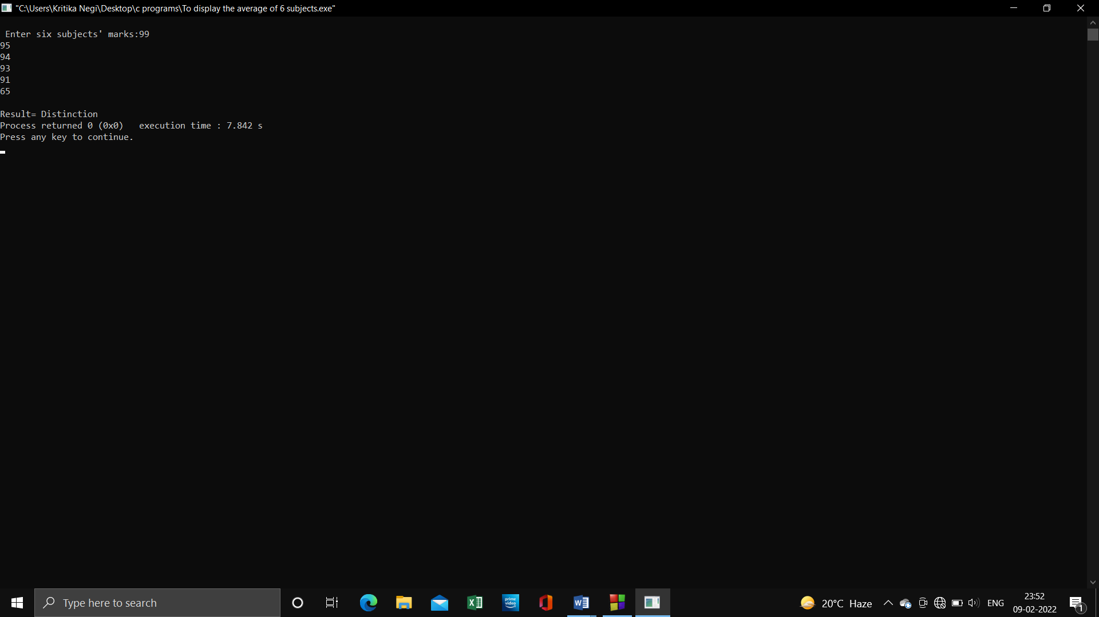**Source Code:**

#include <stdio.h>

int main()

{

int a,b,c,d,e,f,avg;

printf("\n Enter six subjects' marks:");

scanf("%d%d%d%d%d%d",&a,&b,&c,&d,&e,&f);

avg=(a+b+c+d+e+f)/6;

if (avg>=35&&avg<50)

printf("\n Result=Third Division");

if (avg>=50&&avg<60)

printf("\nResult= Second Division");

if (avg>=60&&avg<75)

printf("\n Result=First Division");

if (avg>=75&&avg<100)

printf("\nResult= Distinction");

return 0; }

**Program 19: To find the factorial value of any number entered through the keyboard.**

**Source Code:**

#include <stdio.h>

int main()

{

int i, fac=1;

printf("\nEnter the number to find factorial of:");

scanf("%d",&i);

while (i>=1)

{

fac=fac*i;

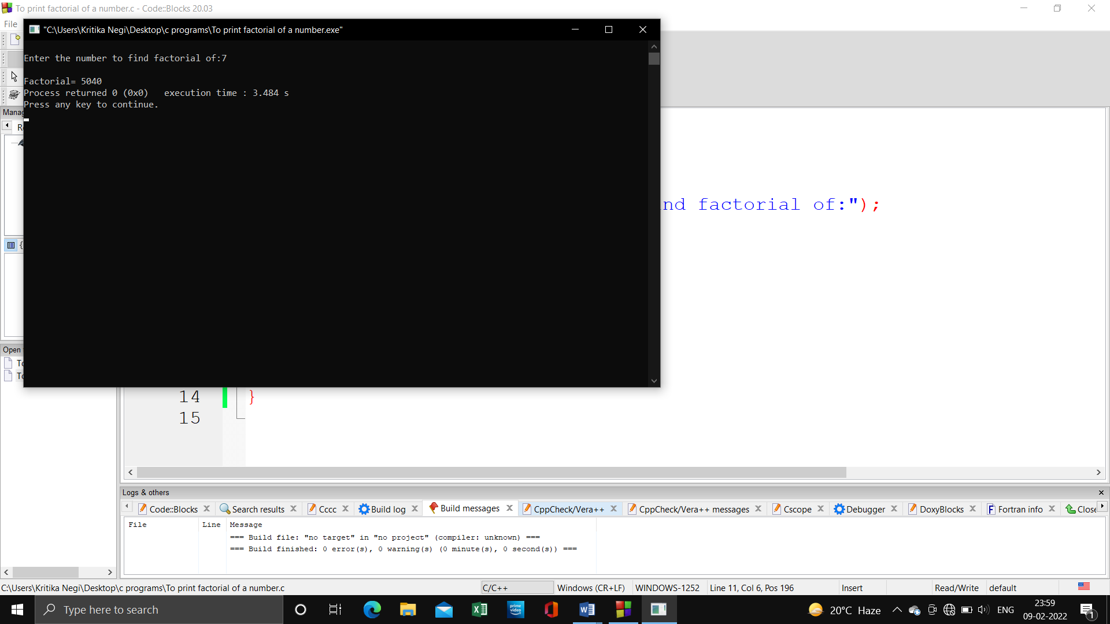 i--;

}

printf("\nFactorial= %d",fac);

return 0;

}

**Program 20: To print all Armstrong number between 1 and 500.**

**Source Code:**

#include<stdio.h>

int main(){

int num, v ,sum,t=1;

for(t=1;t<=500;t++){

num=t;

sum=0;

while(num){

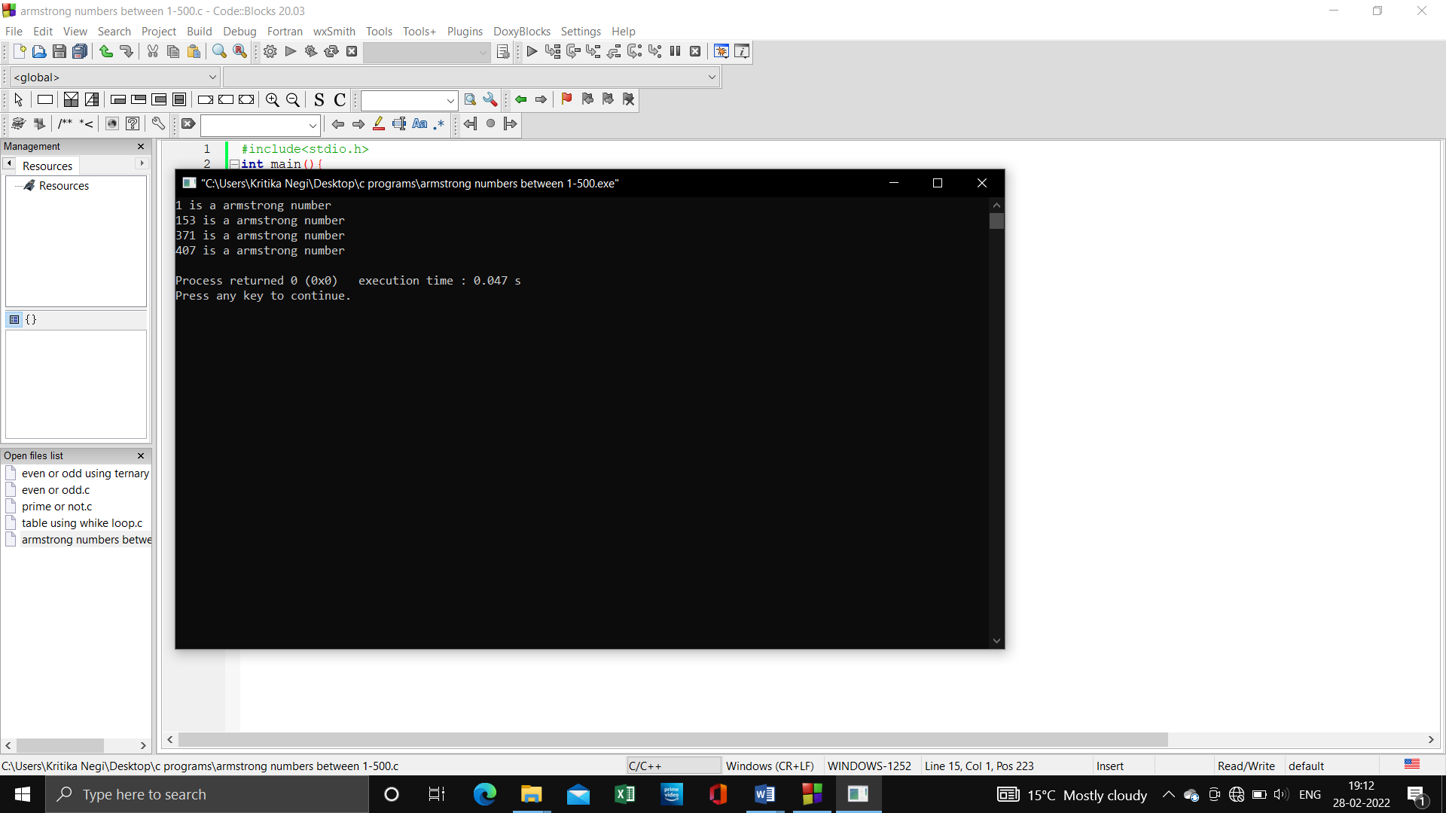v=num%10;

sum=sum+(v*v*v);

num=num/10;}

if(v==sum)

{

printf("%d is a armstrong number\n",t);}

t++;

}

return 0; }

**Program 21: Two numbers are entered through keyboard. Find value of 1 raised to the power of another.**

**Source Code:**

#include<stdio.h>

#include<conio.h>

#include<math.h>

int main()

{

    int x, y, z;

    printf("Enter the value of z: ");

    scanf("%d", &z);

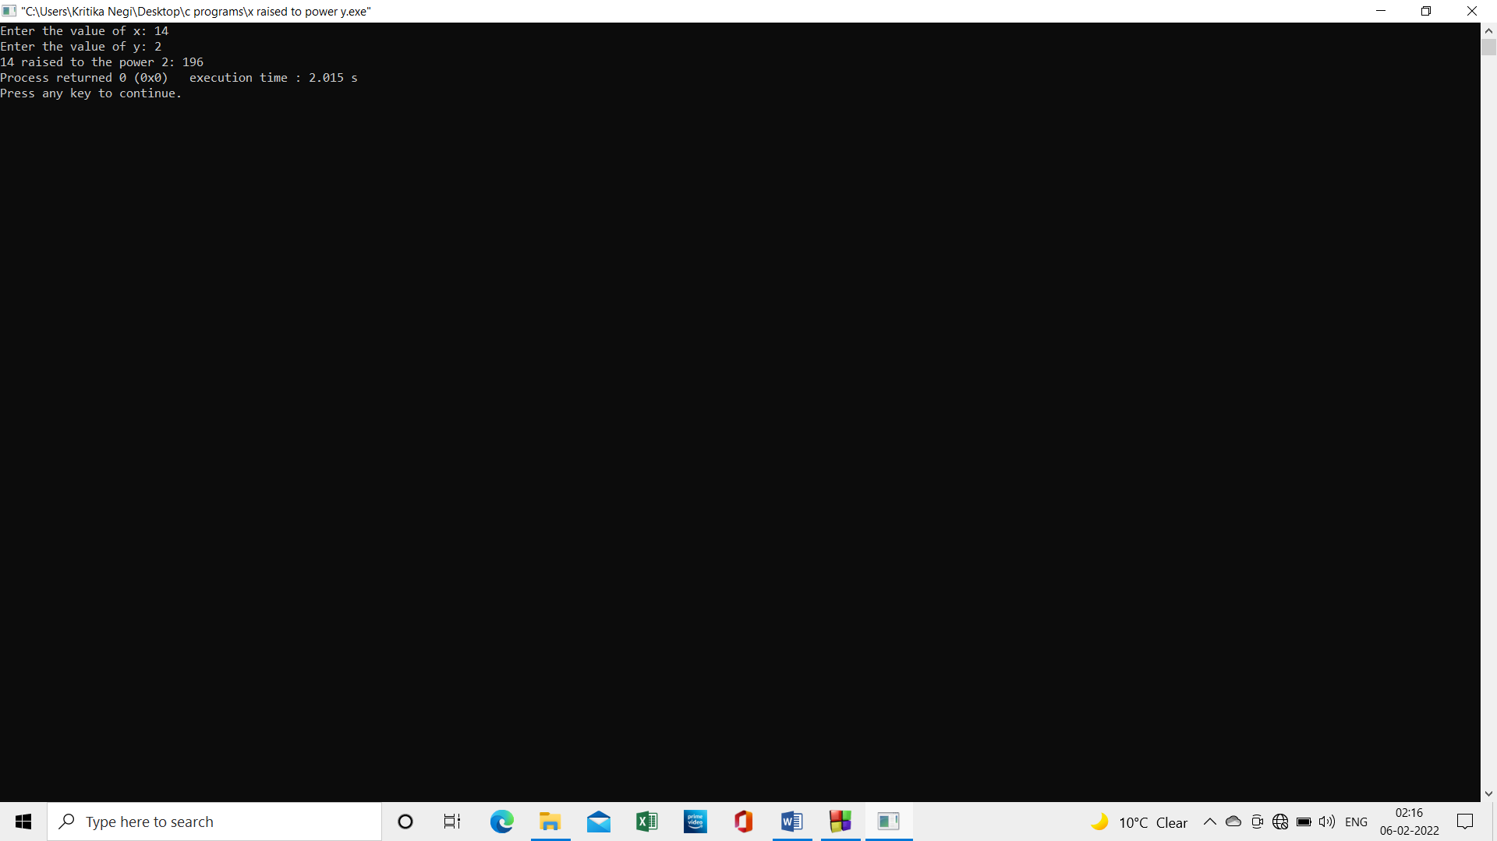    printf("Enter the value of y: ");

    scanf("%d", &y);

z = pow(x,y);

    printf("%d raised to the power %d: %d" ,x,y,z);

}

**Program 22: Write a program to print all the odd and even numbers from 1-100.**

**Source Code:**

#include<stdio.h>

#include<conio.h>

void main()

{

int i,j;

printf("even numbers:\n");

for(i=2;i<=100;i=i+2){printf("%d,",i);}

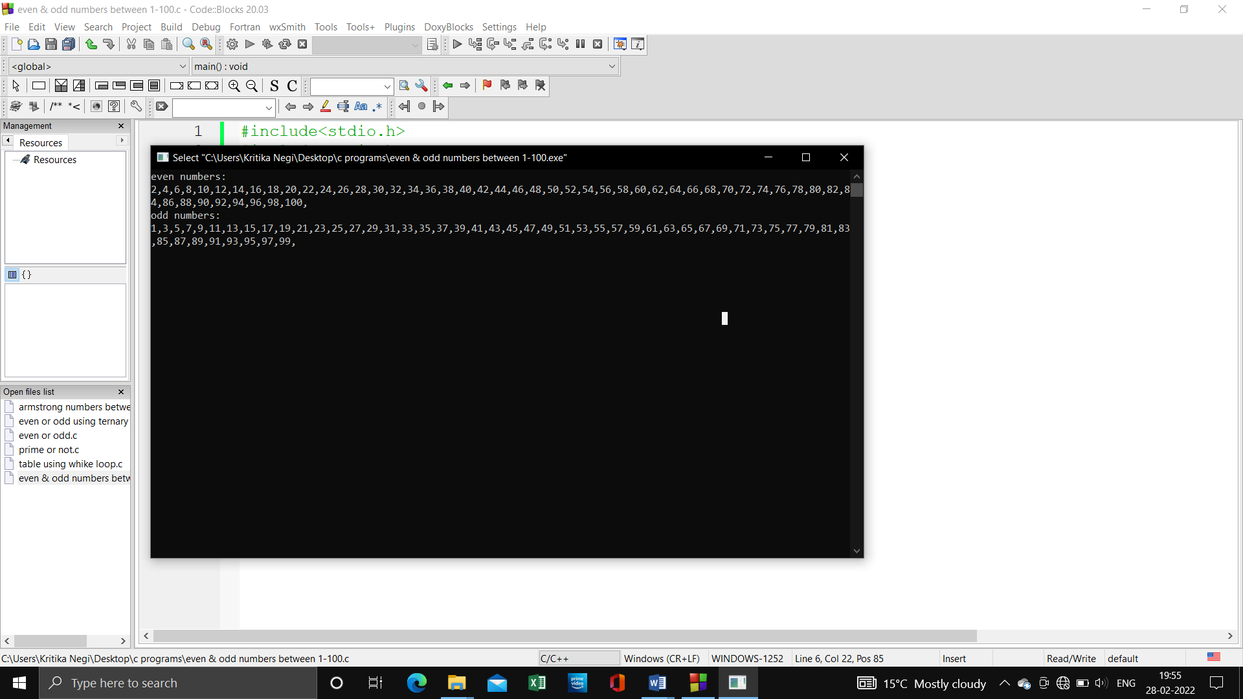printf("\nodd numbers:\n");

for(i=1;i<100;i=i+2)

printf("%d,",i);

getch();

}

**Program 24: Write a program to find if the number is factorial, Prime or not, odd or even and exit using switch case.**

**Source Code:**

#include<stdio.h>

int main()

{int choice;

while(1)

{

printf("\n1. Factorial");

printf("\n2. Prime");

printf("\n3. odd/even");

printf("\n1. your Choice?");

scanf("%d",&choice);

int i,n,fact = 1,a,c=2,num;

switch(choice)

{ case 1:

printf("Enter a number to calculate it's factorial\n");

scanf("%d", &n);

for (i= 1; i <= n; i++)

fact = fact * i;

printf("Factorial of %d = %d\n", n, fact);

break;

case 2:

printf("Enter a number to check if it is prime\n");

scanf("%d",&a);

for ( c = 2;c<= a-1;c++)

{

if ( a%c == 0 )

{

printf("%d is not prime.\n", a);

break;

}

}

if ( c == a)

printf("%d is prime.\n", a);

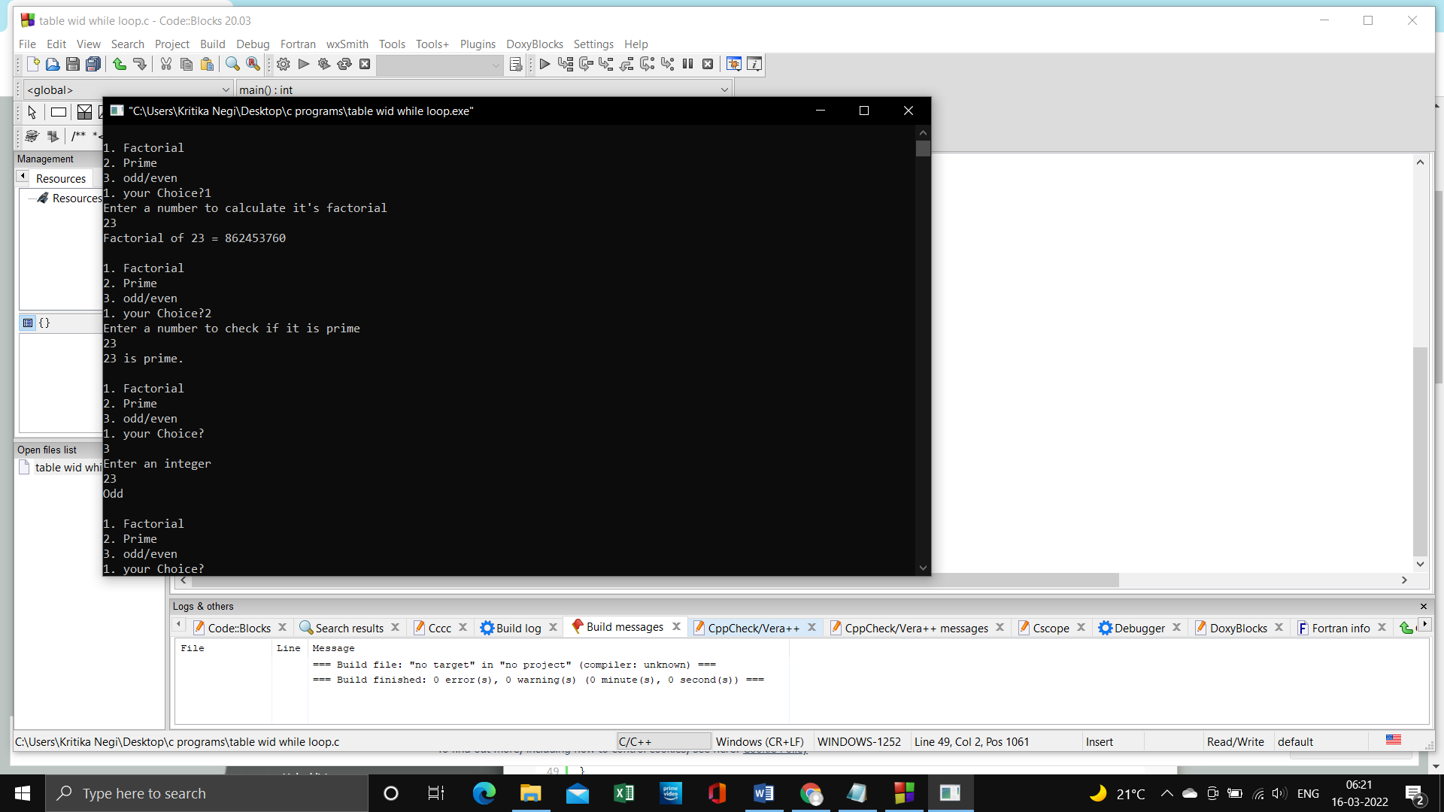

break;

case 3:

printf("Enter an integer\n");

scanf("%d",&num);

if ( num%2 == 0 )

printf("Even\n");

else

printf("Odd\n");

break;

}

**}**

**return 0;}**

**Program 25: Write a menu driven program to construct a calculator for following arithmetic operations: Addition, Subtraction, Multiplication, division, average and percentage.**

**Source Code:**

#include<stdio.h>

int main(){

    char op;

    int num1,num2;

    printf("Choose Your operator = (+ - * /  A P):   ");

    scanf("%c",&op);

    printf("Enter your Two number  =    ");

    scanf("%d%d",&num1,&num2);

    switch (op){

        case '+':

            printf("Addition is %d ",num1+num2);

            break;

        case '-':

            printf("Subtraction is %d ",num1-num2);

            break;

        case '*':

            printf("Multiply is %d ",num1*num2);

            break;

        case '/':

            printf("Divide is %d ",num1/num2);

            break;

        case 'A':

            printf("Average is %d ",(num1+num2)/2);

            break;

        case 'P':

            printf("Percentage is %d ",(num1+num2)/2);

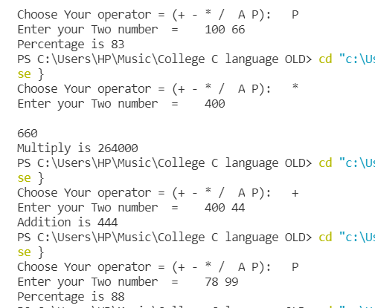            break;

        default:

            printf("Error operator is Not Correct \n");

            break;

        }

    return 0; }

**Program 26: The distance between two cities in km is input through the keyboard write a program to convert and print the distance in meter, feet, inches and centimeters.**

**Source Code:**

#include<stdio.h>

int main()

{

    float km ,m ,cm ,feet ,inches;

    printf("enter distance b/w two cities(in km) = ");

    scanf("%f", &km);

    m = 1000*km;

    cm = 1000*100*km;

    feet = 3280.84*km;

    inches = 39370.1*km;

    printf("distance b/w two cities in meters= %.2f\n" ,m);

    printf("distance b/w two cities in feet= %.2f\n" ,feet);

    printf("distance b/w two cities in centimeters= %.2f\n" ,cm);

    printf("distance b/w two cities in inches = %.2f\n" ,inches);

    return 0;

}

**Program 27:** **Write a menu driven program to perform following Operations:**

**1. Print Armstrong number upto N**

**2. Display your Prime number i to N**

**3. Reverse of an Integers**

**Source Code:**

#include<stdio.h>

int main(){

    int num,i,choice,reverse=0,rem,sum,max;

    printf("choice 1 for Armstrong number \n ");

    printf("choice 2 for check Prime or not \n ");

    printf("choice 3 for reverse your integer(num) \n ");

    printf("Enter Your choice \n");

    scanf("%d",&choice);

    printf("Enter your num \n");

    scanf("%d",&num);

    switch (choice){

    case 1:

        for (i = 1; i < 50000 ; i++){

            num=i;

            sum=0;

            while (num){

                rem = num %10;

                sum=sum+(rem*rem*rem);

                num=num/10;

            }

            if (!(i==num)){

                printf(" Entered number not a Amstrong number ");

                break;

            }

            else if (i==sum){

                printf("Entered  is a Amstrong number \n");

            }

        }

            break;

     case 2:

        for (int i = 2; i <num; i++){

            if (num%i==0){    printf("NOT A Prime number ");  break;  }

        }

        if (num==i){    printf("Prime number ");   }

        break;

     case 3:

        printf("reverse of integer ");

        while (num!=0){

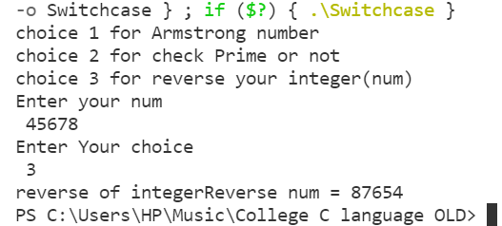            rem=num%10;

            reverse=reverse*10+rem;

            num/=10;                 //(num=num/10)

        }

        printf("Reverse num = %d",reverse);

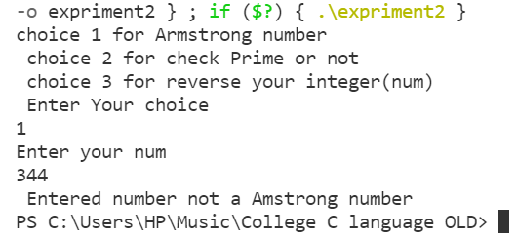        break;

     default:

        break;

    }

    return 0; }  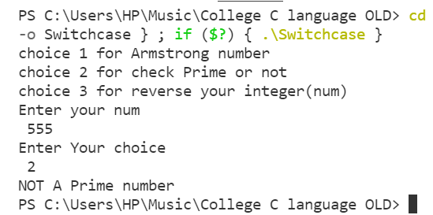

**Program 28:** **Write a program in C to swap two number using call by value**.

**Source Code:**

#include<stdio.h>

int swap(int,int);

int main(){

int a=10,b=20;

swap(a,b);

return 0;

}

int swap(int a,int b){

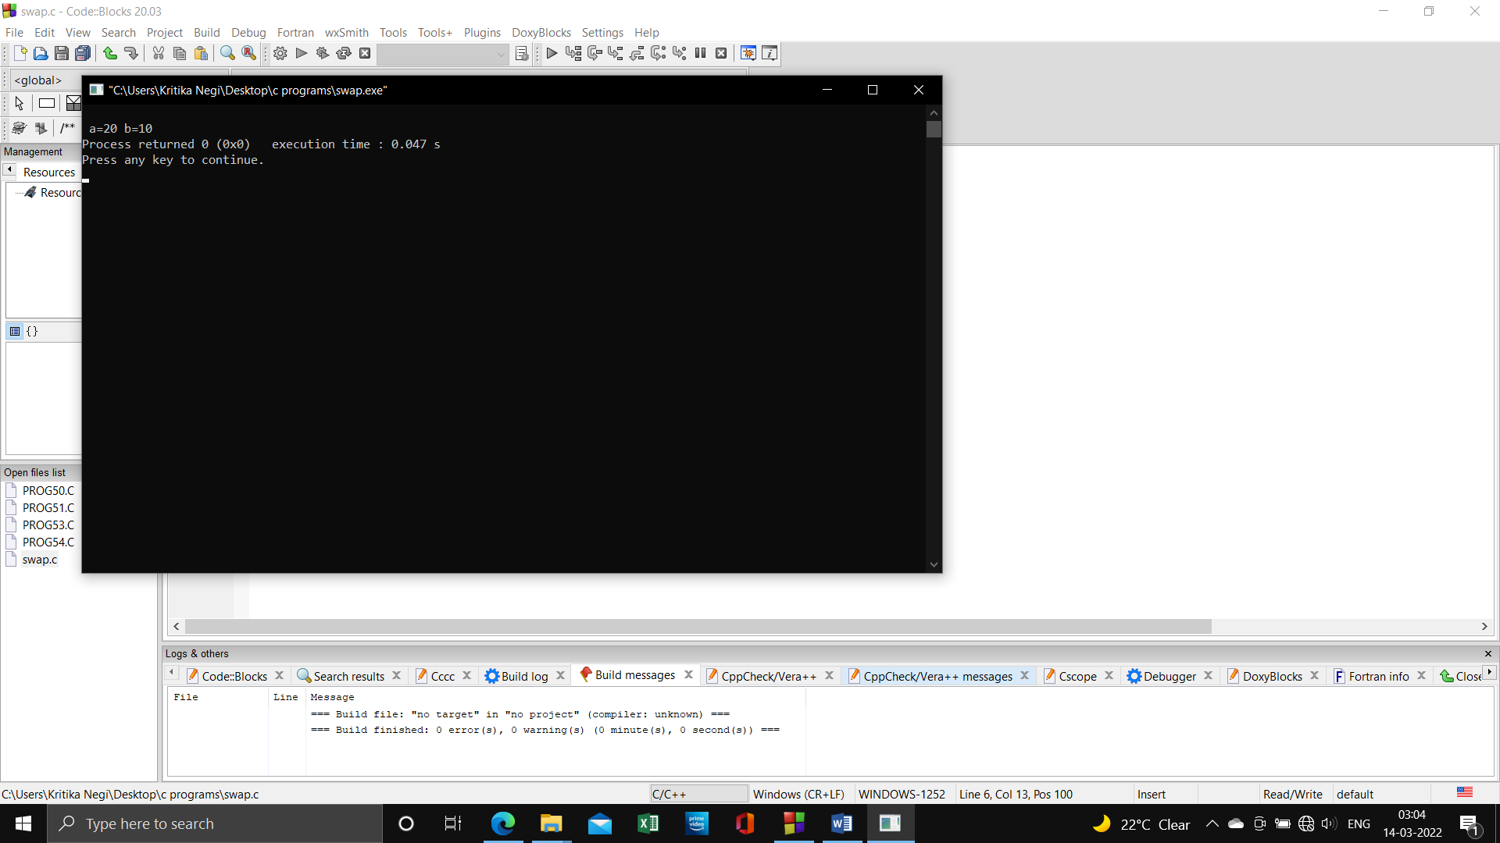 int temp;

temp =a;

a = b;

b = temp;

printf("\n a=%d b=%d",a,b);

}

**Program 29: Write a program in C to swap two number using call by reference**.

**Source Code:**

#include<stdio.h>

#include<conio.h>

void swap(int*,int*);

void main()

{

int a,b;

clrscr();

printf("enter 2 numbers:\n a=");

scanf("%d",&a);

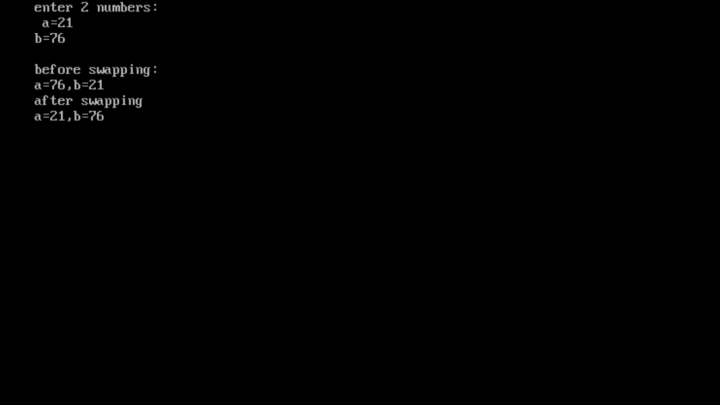printf("b=");

scanf("%d",&b);

printf("\nbefore swapping:\na=%d,b=%d");

printf("\nafter swapping\n");

swap(&a,&b);

getch();}

void swap(int *a,int *b){

int temp;

temp=*a;

*a=*b;

*a=temp;

printf("a=%d,",*a);

printf("b=%d",*b);

}

**Program 30: To calculate area and perimeter of a circle using call by reference.**

**Source Code:**

#include<stdio.h>

void areaperi(int, float* ,float*);

int main(){

   int radius;

   float area ,perimeter;

   printf("radius of circle = \n");

   scanf("%d",&radius);

   areaperi(radius,&area,&perimeter);

   printf("Area =%f",area);

   printf("premeter = %f",perimeter);

  return 0;

}

void areaperi(int r,float *a,float *p){

      *a=3.14*(r)*(r);

      *p=2*3.14*(r);

}

**Program 31: To add, subtract, multiply and divide two numbers using pointers.**

**Source Code:**

#include<stdio.h>

int add(int*,int*);

int Sub(int*x,int*y);

int Mult(int*x,int*y);

int Divide(int*x,int*y);

int main(){

   int a,b,sum,sub,mul,div;

   printf("\n Enter your two number =   ");

   scanf("%d %d",&a,&b);

   sum=add(&a,&b);

   sub = Sub(&a,&b);

   mul=Mult(&a,&b);

   div = Divide(&a,&b);

   printf("this is sum = %d\n",sum);

   printf("this is subtract = %d\n",sub);

   printf("this is Multiply = %d\n",mul);

   printf("this is Divide = %d\n",div);

   return 0;

}

int add(int*x,int*y){

      int sum;

      sum =(*x)+(*y);

      return sum;

}

int Sub(int*x,int*y){

      int sub;

      sub =(*x)-(*y);

      return sub;

}

int Mult(int*x,int*y)

{

      int M;

      M =(*x)*(*y);

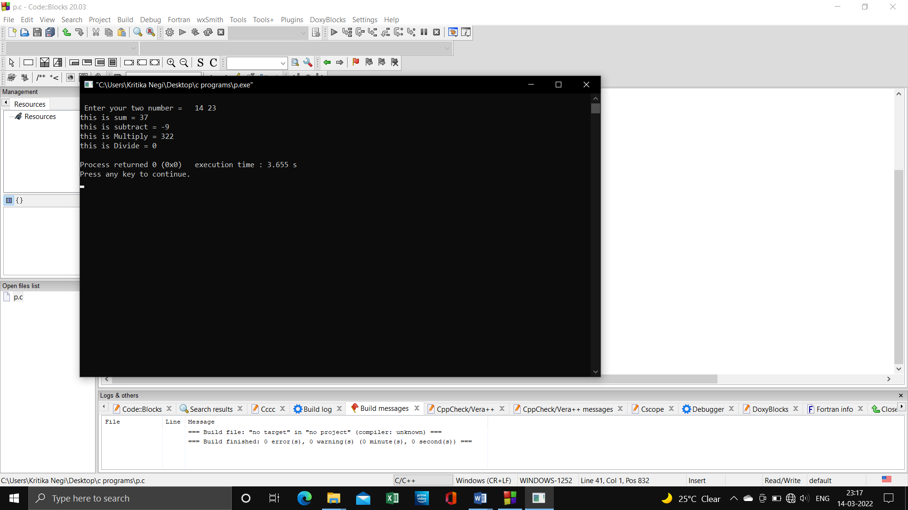      return M;

}

int Divide(int*x,int*y){

      int Div;

      Div =(*x)/(*y);

      return Div;

}

**Program 32: To input marks of 50 students using an array and display the average marks of the class.**

**Source Code:**

#include<stdio.h>

int main()

{

    int marks[50],sum=0,Avg;

    printf("Enter Marks of 50 student = ");

    for (int i = 0; i < 50; i++)

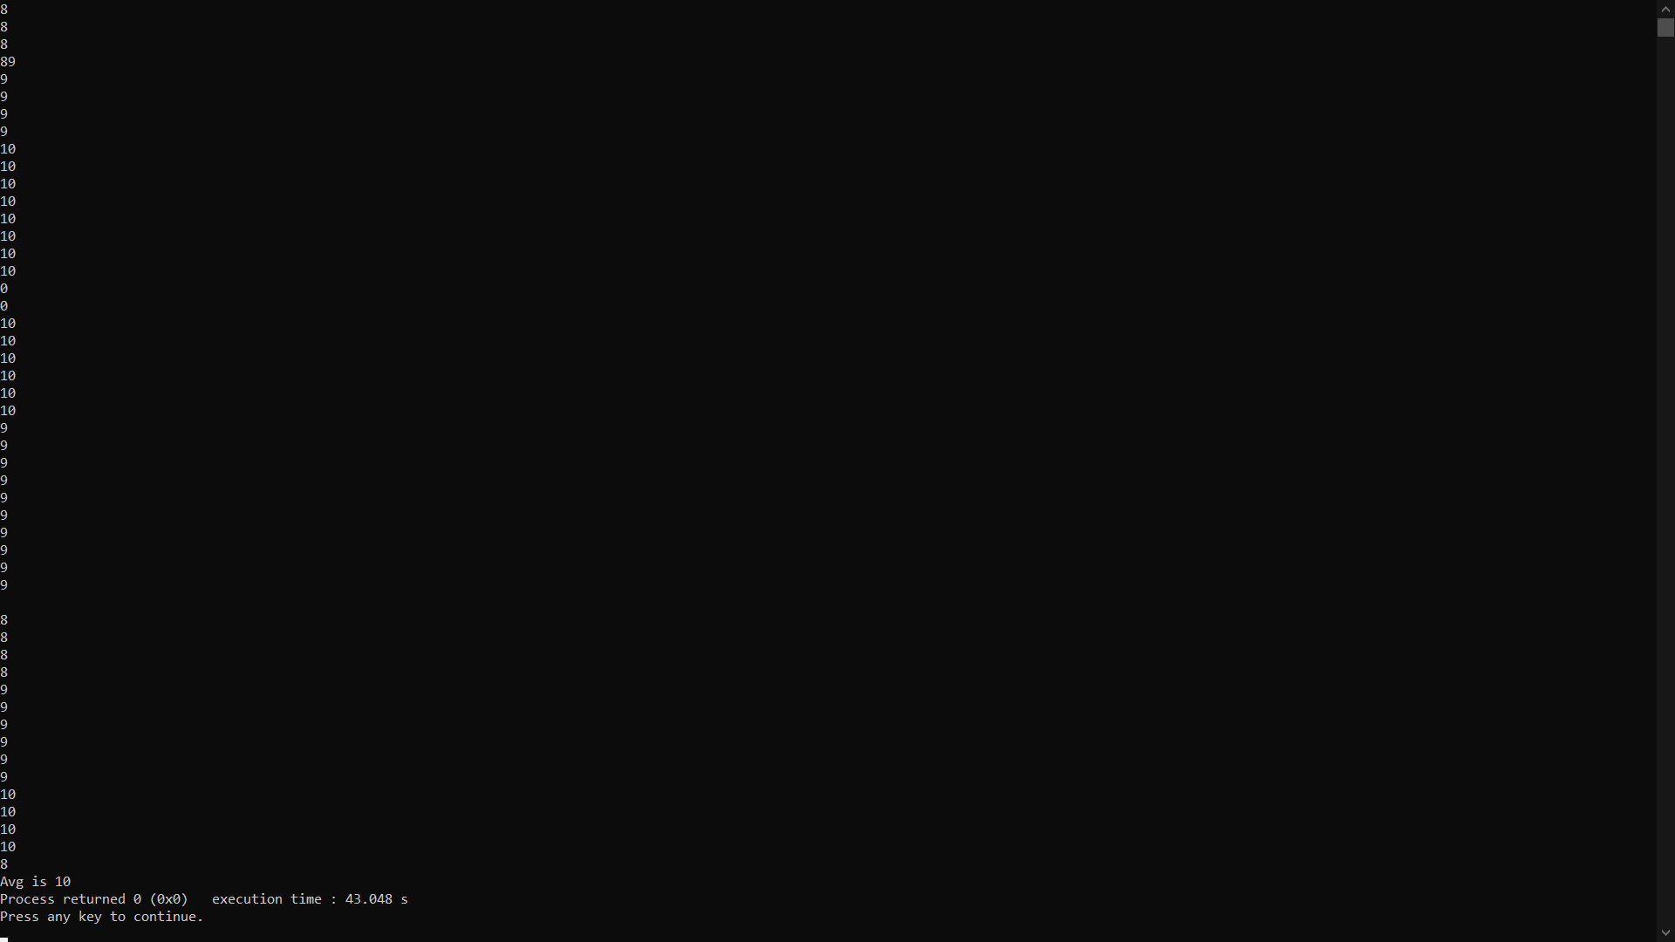    {

        scanf("%d",&marks[i]);

        sum=sum+marks[i];

    }

    Avg=sum/50;

    printf("Avg is %d",Avg);

    return 0;

}

**Program 33: To search for a number entered by the user in a given array.**

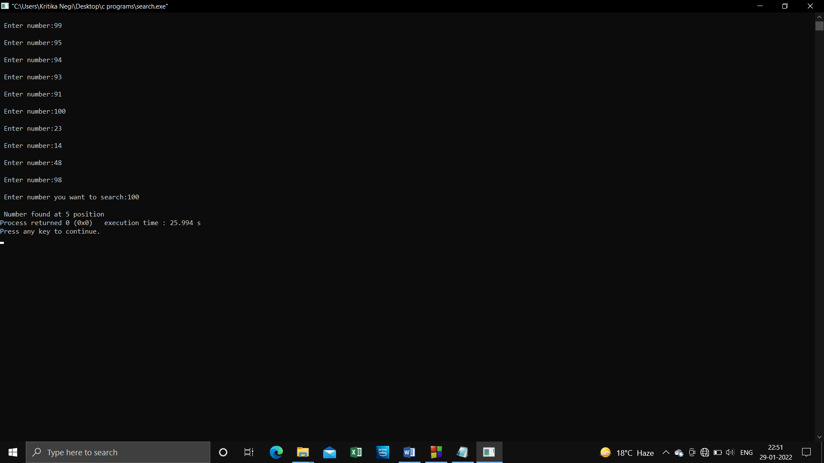**Source Code:**

#include <stdio.h>

int main()

{

int a[10],i,key,pos,flag;

for(i=0 ; i<10; i++)

{

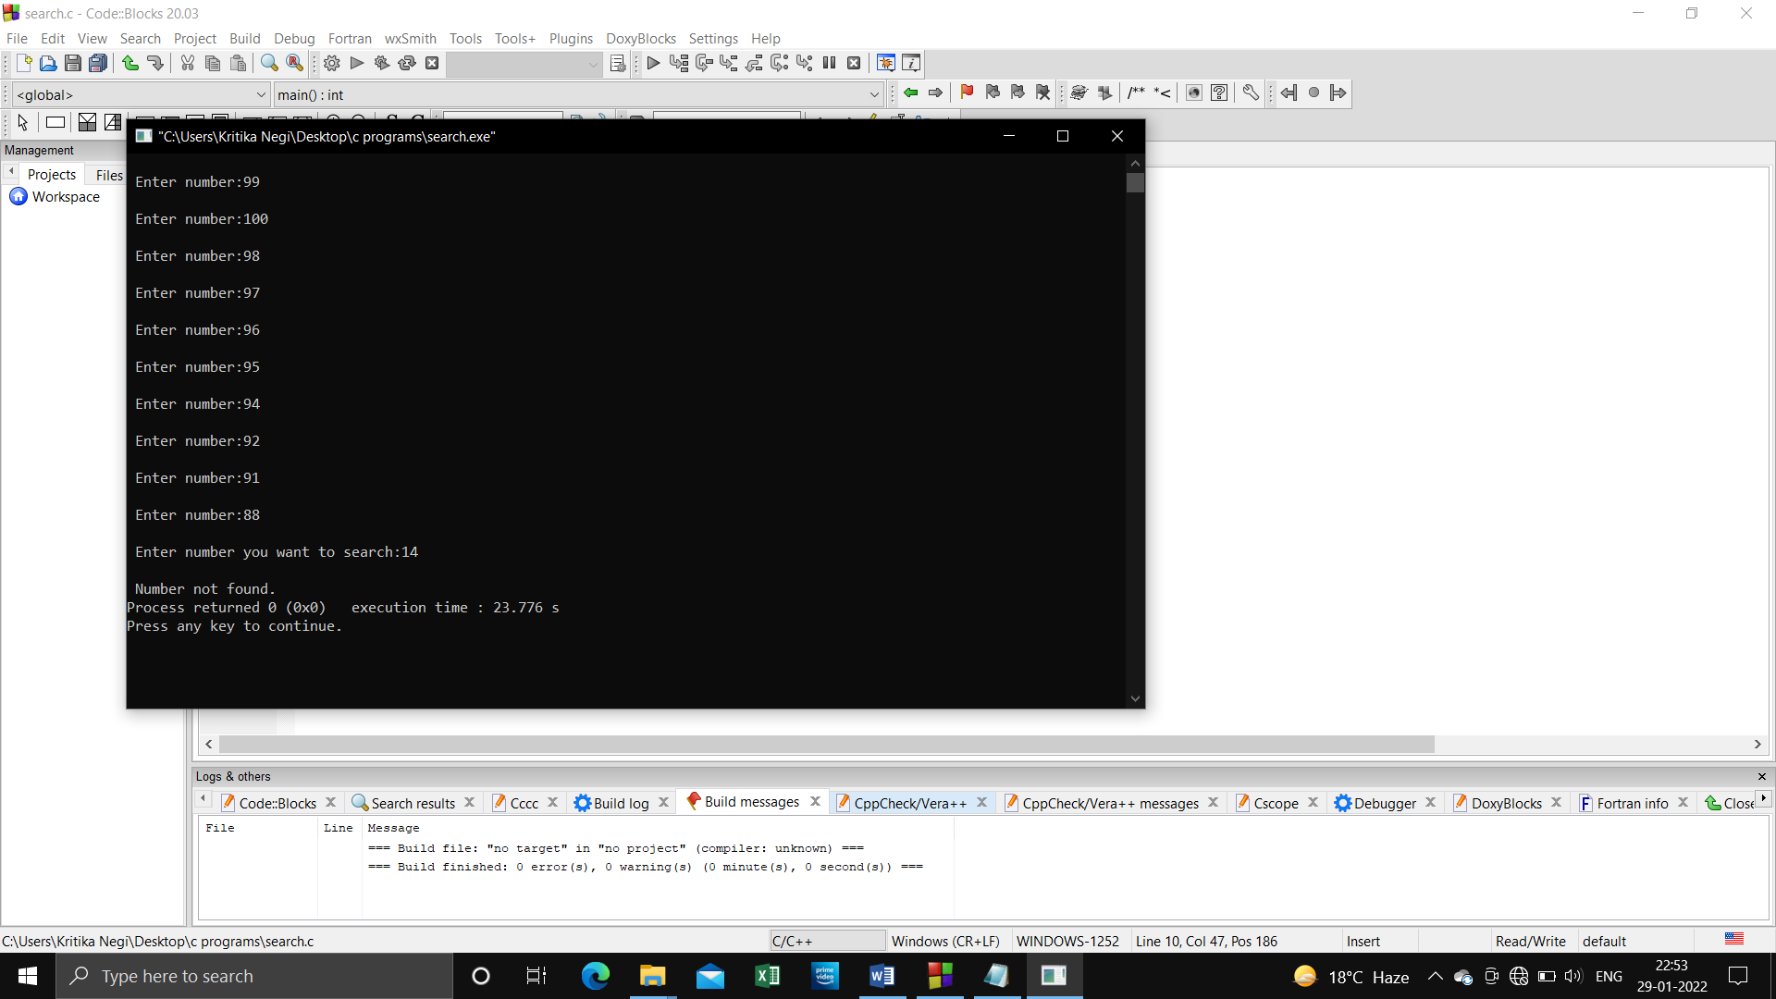printf("\n Enter number:");

scanf("%d", &a[i]);

}

printf("\n Enter number you want to search:");

scanf("%d",&key);

for(i=0;i<10;i++)

{

if(a[i]==key)

{

pos=i++;

flag=1;

break;

}

}

if (flag==1)

printf("\n Number found at %d position",pos);

else

printf("\n Number not found.");

return 0;

}

**Program 34: To pass array elements to a function by call by value.**

**Source Code: :** #include<stdio.h>

void display(int);

int main(){int i;

    int  marks[]={66 ,77, 88, 99, 80};

    for ( i = 0; i < 5; i++)

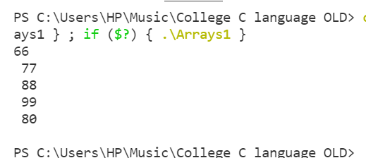    display(marks[i]);

return 0;

}

void display(int m){

      printf("%d \n ",m);

}

**Program 35: To pass array elements to a function by call by reference.**

**Source Code:** #include<stdio.h>

void display(int);

int main(){int i;    int  marks[]={66 ,77, 88, 99, 80};

    for ( i = 0; i < 5; i++)

    display(marks[i]);

return 0;

}

void display(int m){

      printf("%d \n ",m);

}

**Program 36: To print the given pattern:**

**\***

**\*\***

**\*\*\***

**\*\*\*\***

**\*\*\*\*\***

**Source Code:**

#include<stdio.h>

#include<conio.h>

int main(){

int i,j,n,no;

clrscr();

printf("enter no of rows:");

scanf("%d",&no);

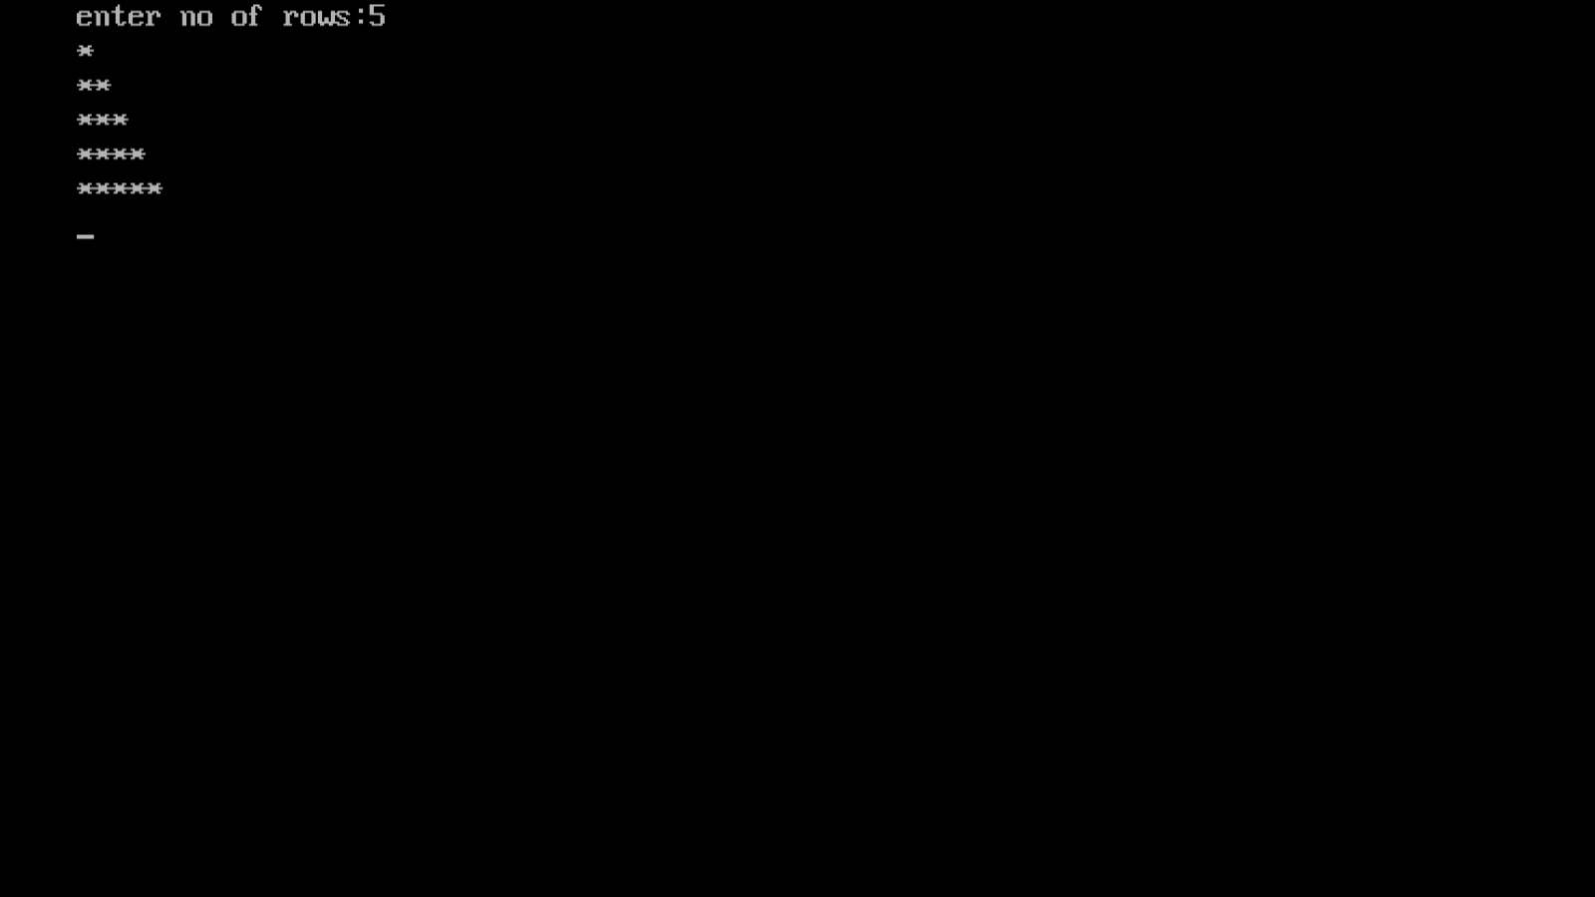for(i=0;i<no;i++){

for(j=0;j<=i;j++){printf("*");}

printf("\n");

}

return 0;

}

**Program 37: To print the inverted half pyramid**

**\*\*\*\*\***

**\*\*\*\***

**\*\*\***

**\*\***

**\***

**Source Code:**

#include<stdio.h>

#include<conio.h>

int main(){

int i,j,rows;

clrscr();

printf("enter the number of rows:");

scanf("%d",&rows);

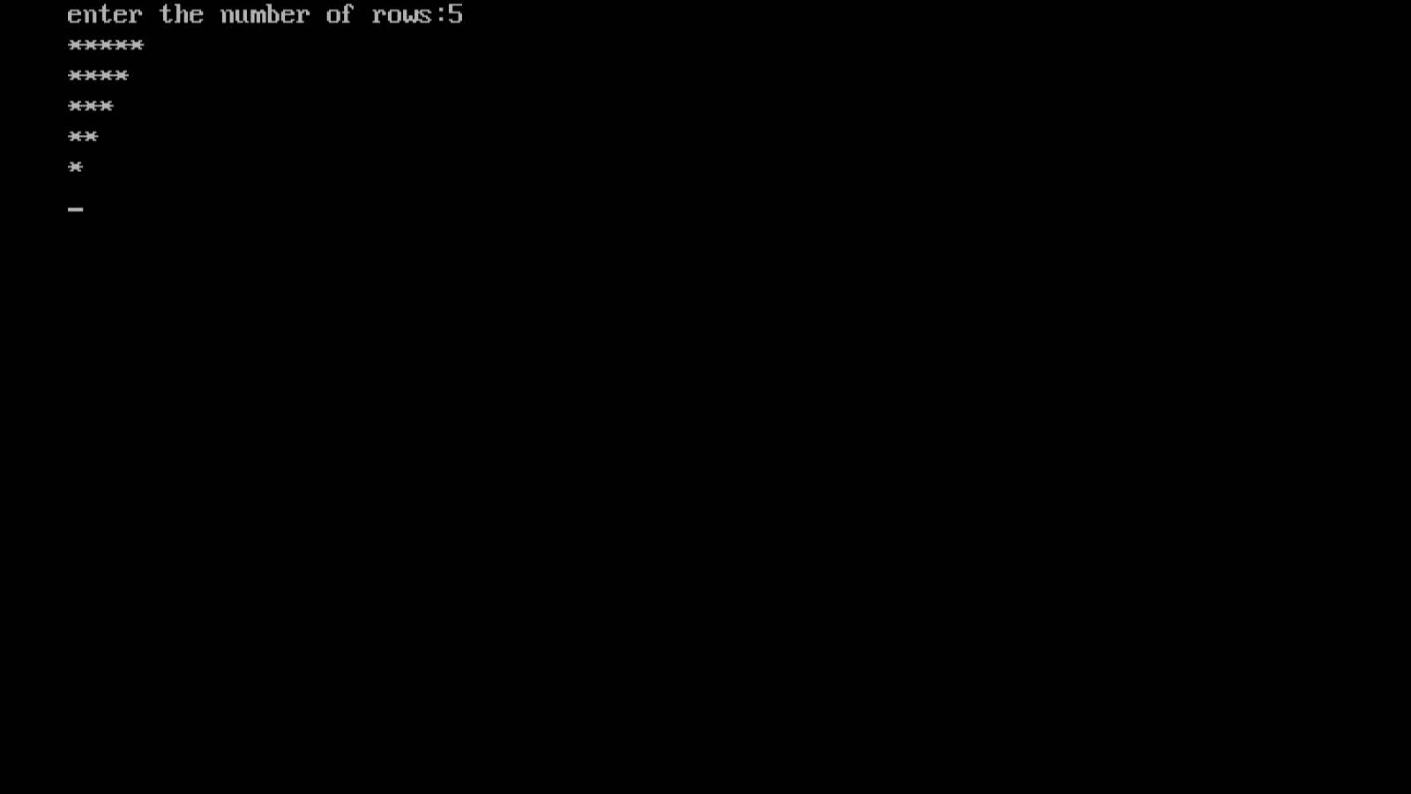for(i=rows;i>=1;i--){

for(j=1;j<=i;j++){printf("*");}

printf("\n");

}

return 0;

}

**Program 38: To print half pyramid of numbers.**

**1**

**12**

**123**

**1234**

**Source Code:**

#include<stdio.h>

#include<conio.h>

int main(){

int i,j,row;

clrscr();

printf("enter the number of rows:");

scanf("%d",&row);

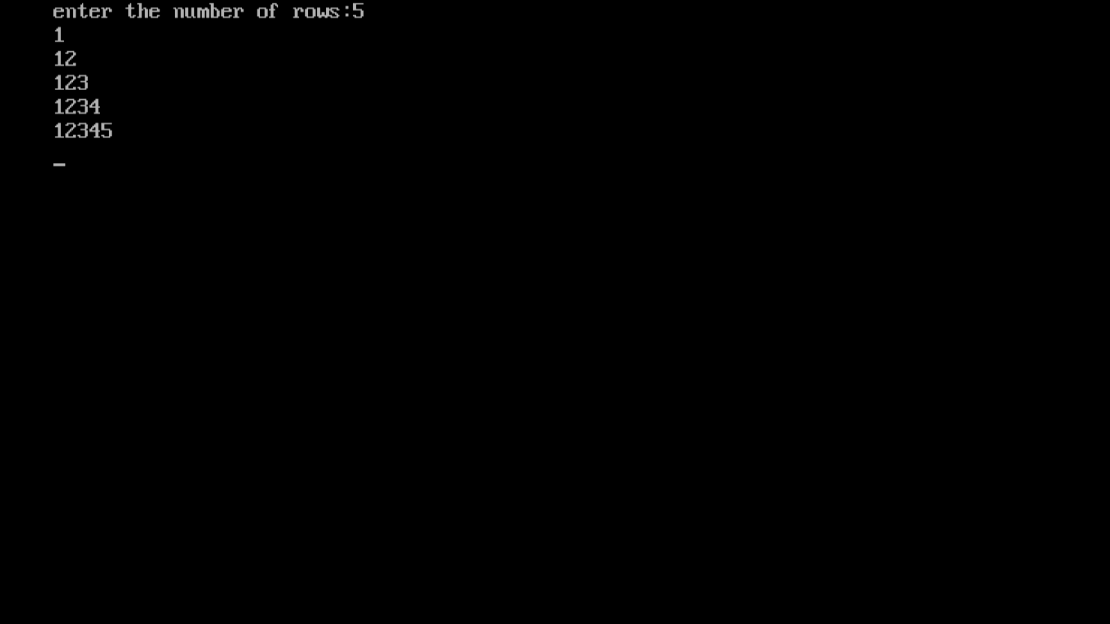for(i=1;i<=row;i++){

for(j=1;j<=i;j++){printf("%d",j);}

printf("\n");

}

return 0;

}

**Program 39: To compute the sum of all elements stored in the array, using pointers.**

**Source Code:**

#include <stdio.h>

int main()

{

int a[10],i, sum=0;

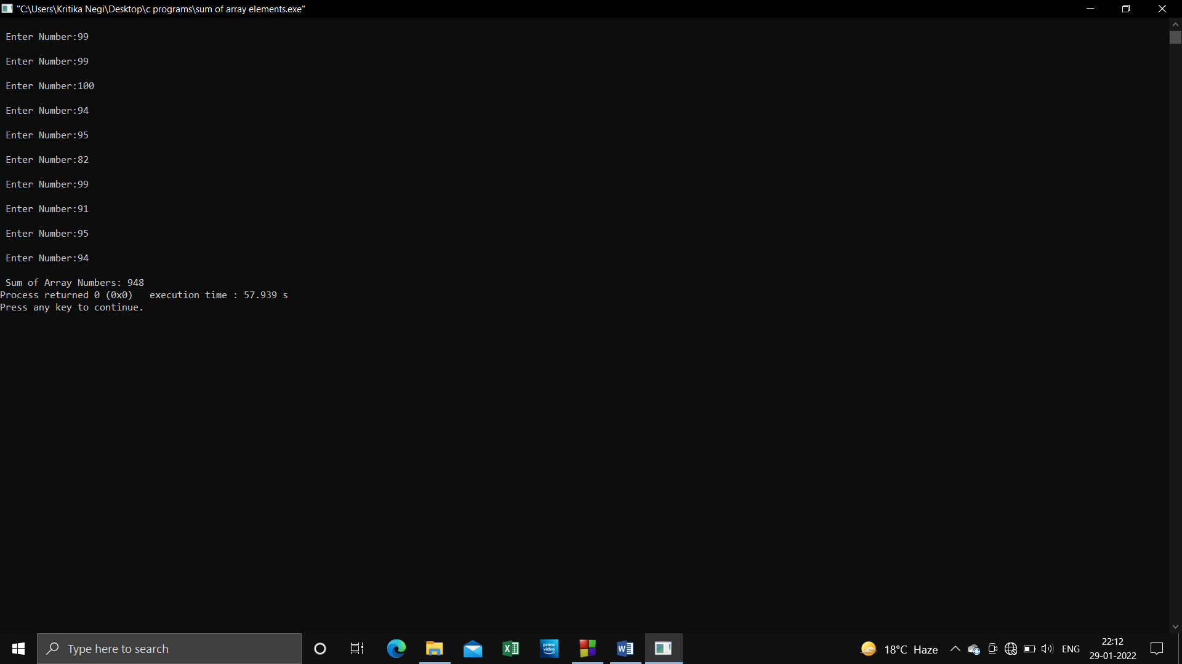for(i=0 ; i<10 ; i++)

{

printf("\n Enter Number:");

scanf("%d",& a[i]);

}

for(i=0 ; i<10 ; i++)

sum=sum+a[i];

printf("\n Sum of Array Numbers: %d",sum);

return 0;

}

**Program 40 : To sort the elements of array in C pointer.**

**Source Code:**

#include<stdio.h>

#include<conio.h>

void sort(int,int*);

int main(){

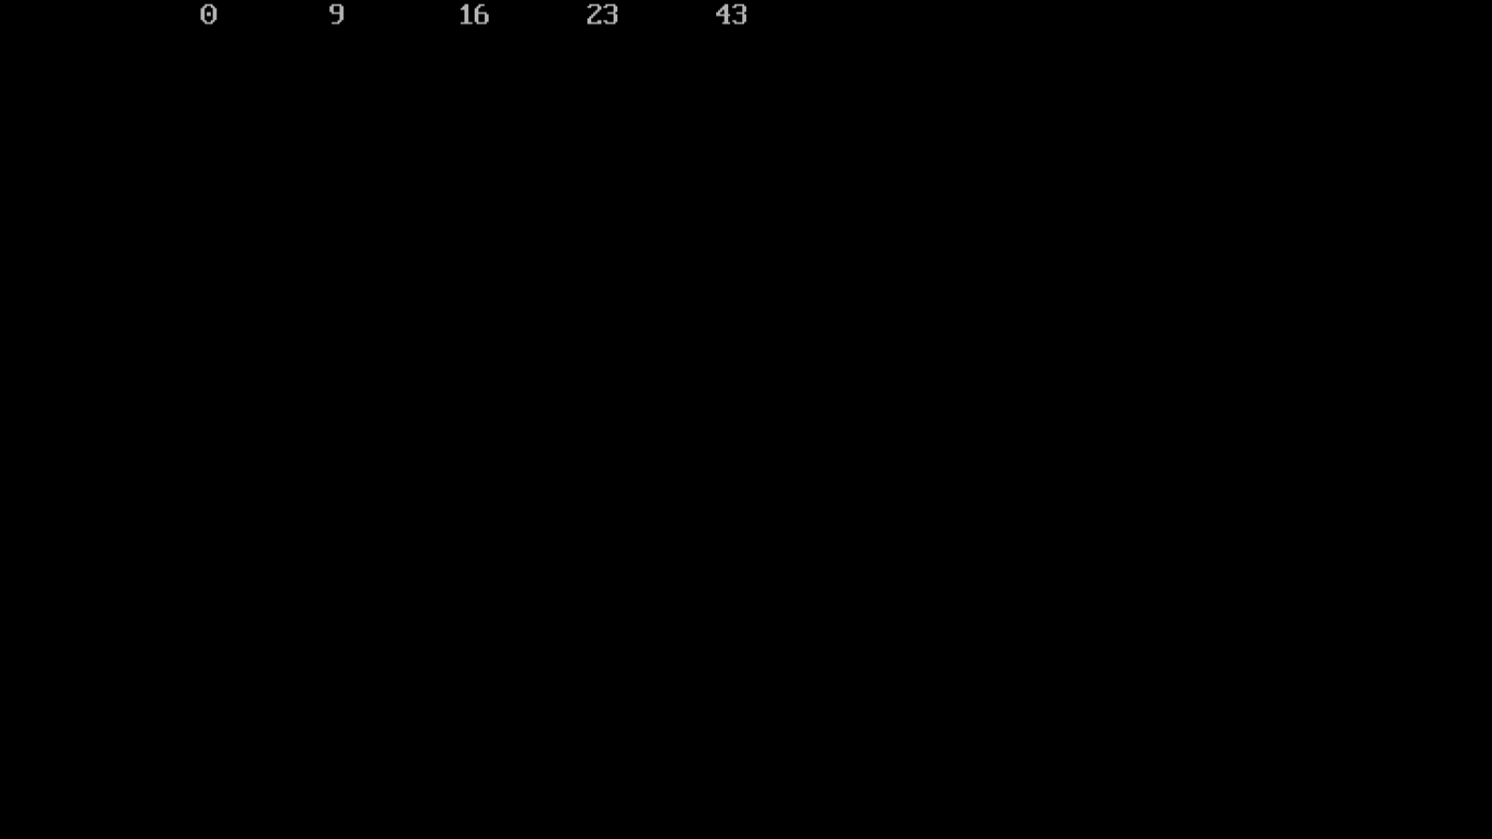int n=5;

int a[]={0,23,43,16,9};

clrscr();

sort(n,a);

return 0;

}

void sort(int m,int*p){

int i,j,temp;

for(i=0;i<m;i++){

for(j=i+1;j<m;j++){

if(*(p+j)<*(p+i)){

temp=*(p+i);

*(p+i)=*(p+j);

*(p+j)=temp; }

}

}

for(i=0;i<m;i++){printf("\t%d",*(p+i));}

}

**Program 41 : To show the use of malloc and free function.**

**Source Code:**

#include<stdio.h>

#include<conio.h>

#include<alloc.h>

void main(){

char *ch;

int *p;

float *f;

ch=(char*)malloc(sizeof(char));

p=(int*)malloc(sizeof(int));

f=(float*)malloc(sizeof(float));

printf("enter a character");

*ch=getchar();

printf("enter a integer");

scanf("%d",p);

printf("enter a float");

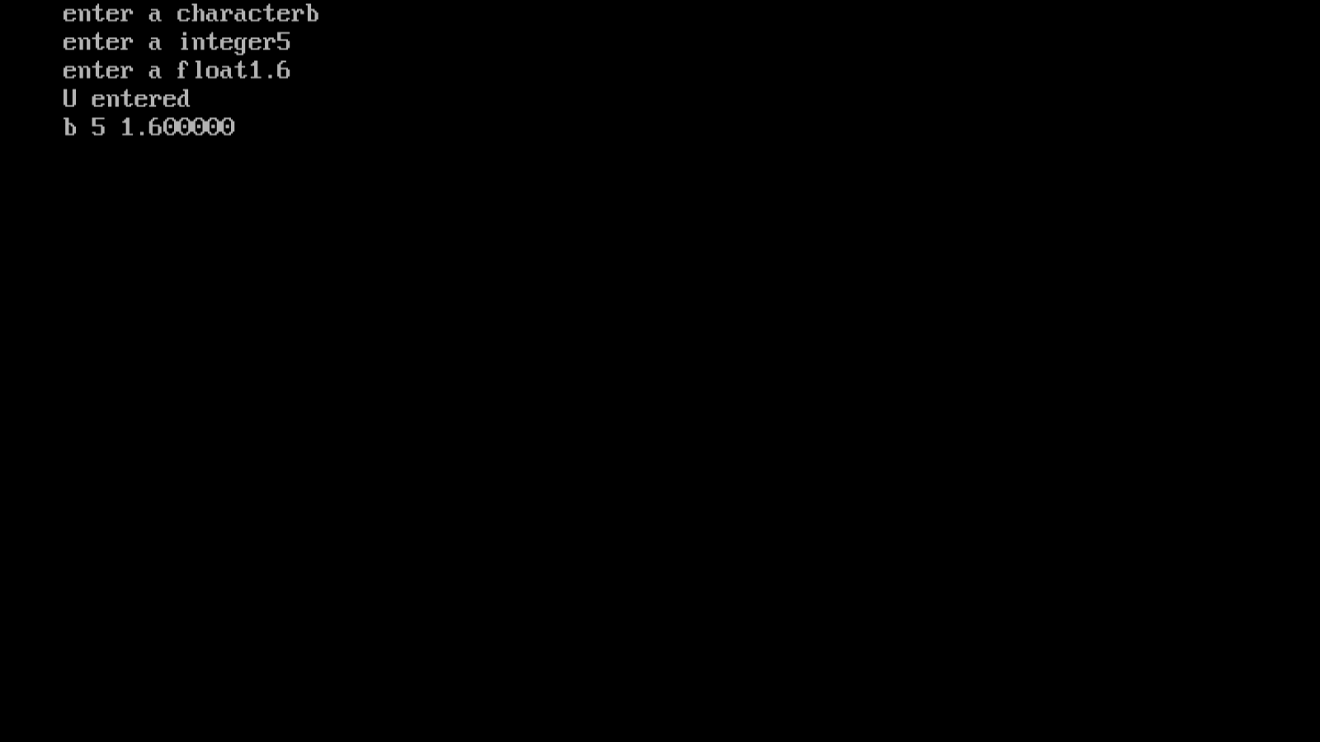scanf("%f",f);

printf("U entered\n%c %d %f",*ch,*p,*f);

free(ch);

free(p);

free(f);

}

**Program 42: To show the concept of dynamic memory allocation for an array.**

**Source Code:**

#include<stdio.h>

#include<conio.h>

#include<alloc.h>

void main()

{

int *p,n,i;

printf("enter the size of array:");

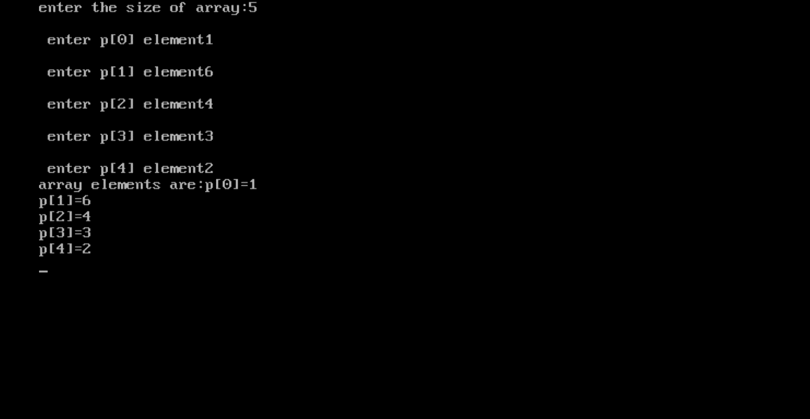scanf("%d",&n);

p=(int*)malloc(sizeof(int)*n);

for(i=0;i<n;i++){

printf("\n enter p[%d] element",i);

scanf("%d",p+i);

}

printf("array elements are:");

for(i=0;i<n;i++){

printf("p[%d]=%d\n",i,*(p+i));

}

free(p);

}

**Program 43 : To perform matrix addition, matrix multiplication & matrix transpose.**

**Source Code:**

#include<stdio.h>

#include<conio.h>

void add(int m[3][3],int n[3][3],int sum[3][3]);

void multiply(int m[3][3],int n[3][3],int mul[3][3]);

void transpose(int matrix[3][3],int trans[3][3]);

void display(int matrix[3][3]);

void main(){

int a[][3]={{5,6,7},{8,9,10},{11,12,13}};

int b[][3]={{1,3,7},{2,4,6},{4,12,8}};

int c[3][3];

int choice;

clrscr();

printf("first matrix:\n");

display(a);

printf("second matrix:\n");

display(b);

do{

printf("\n choose matrix operations:-\n");

printf("1.addition\n");

printf("2.multiplication");

printf("3.transpose");

printf("4.exit\n");

printf("____________________\n");

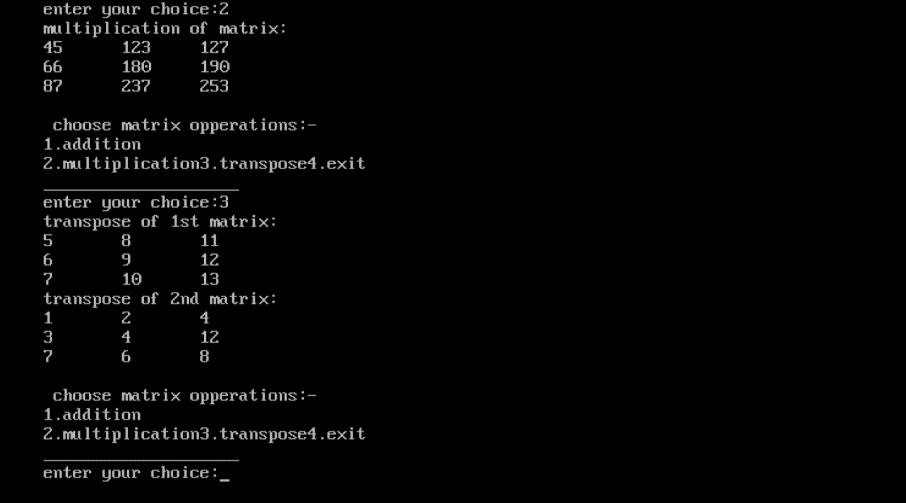printf("enter your choice:");

scanf("%d",&choice);

switch(choice){

case 1:

add(a,b,c);

printf("sum of matrix:\n");

display(c);

break;

case 2:

multiply(a,b,c);

printf("multiplication of matrix:\n");

display(c);

break;

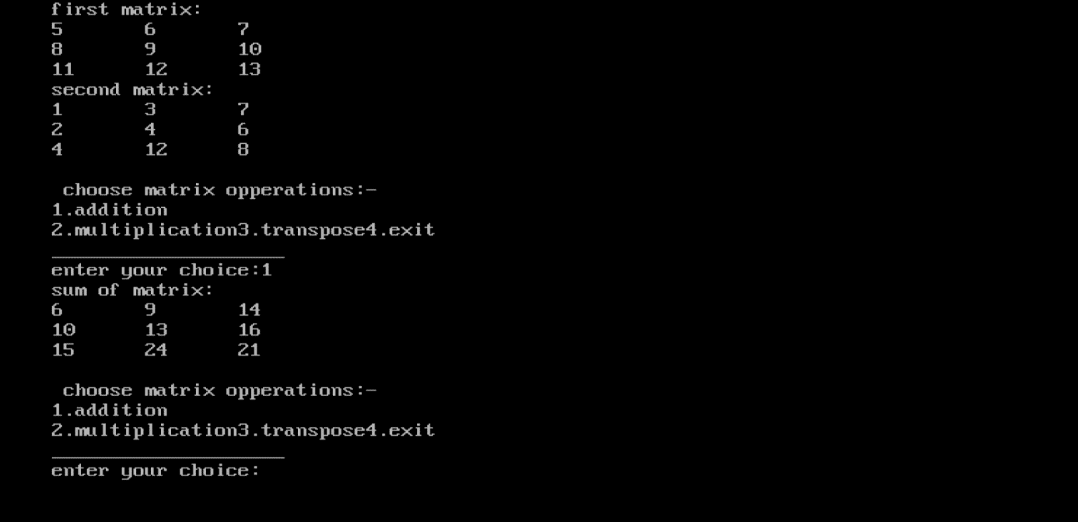case 3:

printf("transpose of 1st matrix:\n");

transpose(a,c);

display(c);

printf("transpose of 2nd matrix:\n");

transpose(b,c);

display(c);

break;

case 4:

printf("thank you.\n");

exit(0);

default:

printf("wrong choice");

}

}

while(1);

}

void add(int m[3][3],int n[3][3],int sum[3][3]){

int i,j;

for(i=0;i<3;i++)

for(j=0;j<3;j++)

sum[i][j]=m[i][j]+n[i][j];

}

void multiply(int m[3][3],int n[3][3],int mul[3][3]){

int i,j,k;

for(i=0;i<3;i++)

for(j=0;j<3;j++)

{

mul[i][j]=0;

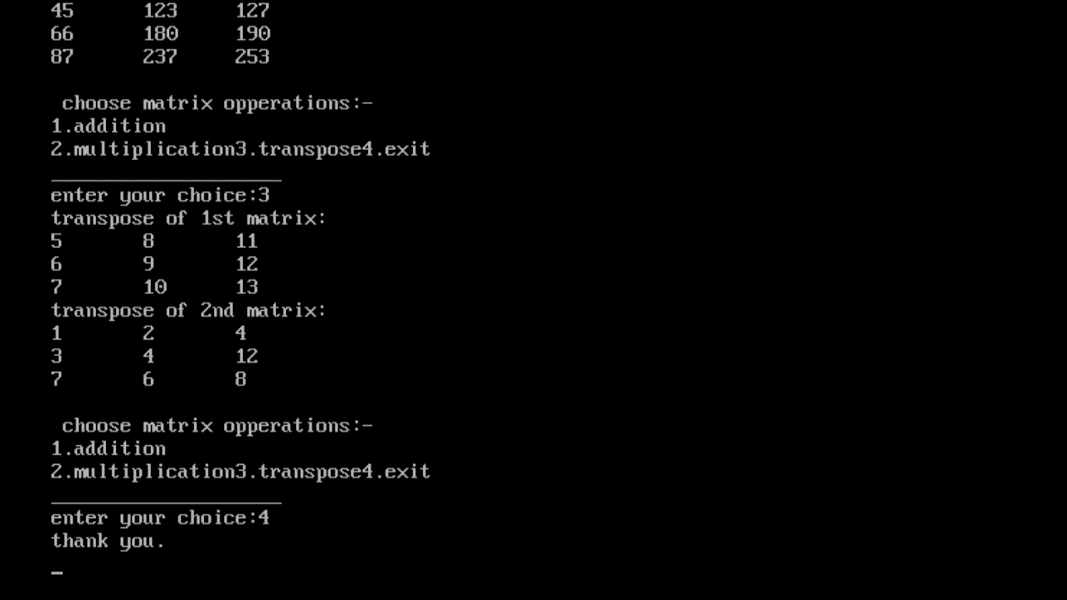for(k=0;k<3;k++){

mul[i][j]+=(m[i][k]*n[k][j]);

}}}

void transpose(int matrix[3][3],int trans[3][3]){

int i,j;

for(i=0;i<3;i++)

for(j=0;j<3;j++)

trans[i][j]=matrix[j][i];

}

void display(int matrix[3][3]){

int i,j;

for(i=0;i<3;i++)

{

for(j=0;j<3;j++)

printf("%d\t",matrix[i][j]);

printf("\n");

}

}

**Program 44 : To check if a string is palindrome or not, using predefined function strcmp.**

**Source Code:**

#include<stdio.h>

#include<conio.h>

#include<string.h>

int main(){

char s1[1000],s2[1000];

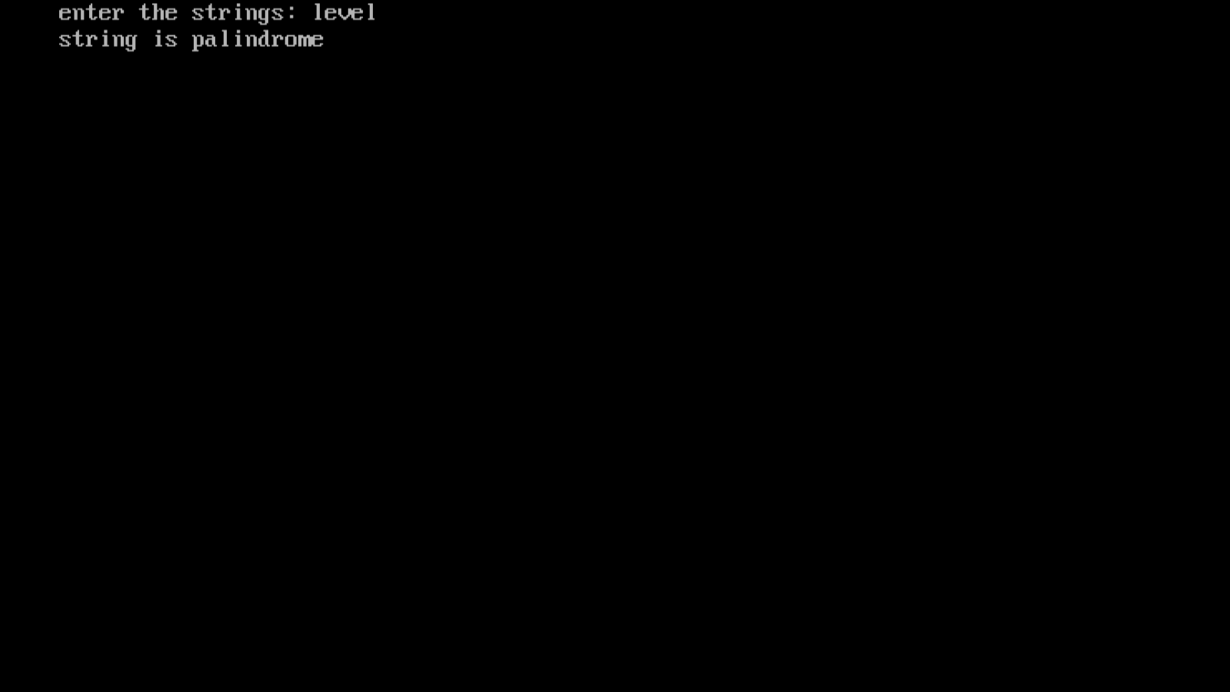printf("enter the strings: ");

gets(s1);

strcpy(s2,s1);

strrev(s2);

if(!strcmp(s1,s2))

printf("string is palindrome");

else

printf("string is not palindrome");

return 0;

}

**Program 45 : To check if a string is palindrome or not, without using predefined function.**

**Source Code:**

#include<stdio.h>

#include<conio.h>

#include<string.h>

int main(){

char s[1000];

int i,n,c=0;

printf("enter the string:");

gets(s);

n=strlen(s);

for(i=0;i<n/2;i++){

if(s[i]==s[n-i-1])

c++;}

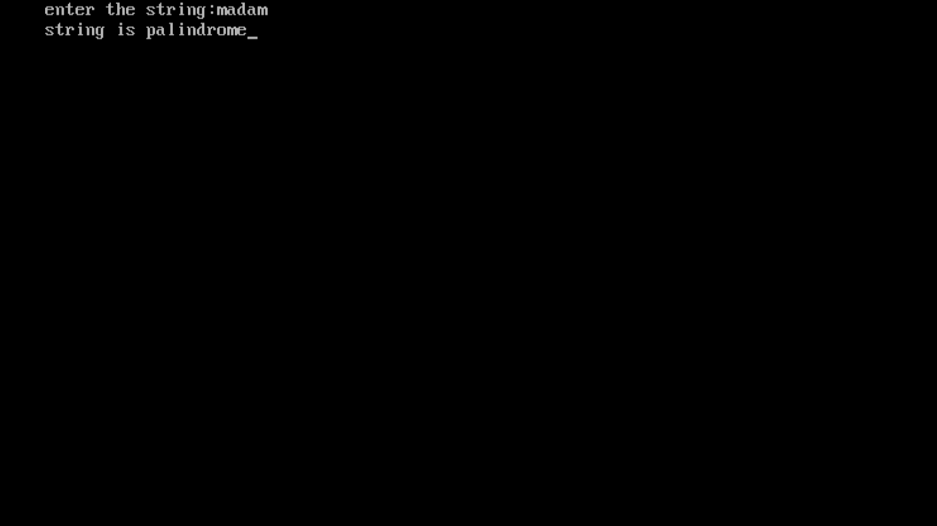if(c==i)

printf("string is palindrome");

else

printf("string is not palindrome");

return 0;

}

**Program 46: Write a menu driven program to implement following operations:**

**(i) Calculate length of string**

**(ii) Concatenate at the end of a given string**

**(iii) Copy one string to another**

**(iv) Compare contents of two strings**

**(v) Copy nth character string to another.**

**Source Code:**

#include<stdio.h>

#include<conio.h>

#include<string.h>

#include<stdlib.h>

int main(){

char str1[20],str2[20];

int choice,I,j;

do

{

printf("\tMENU");

printf("\n----------------------\n");

printf("1. Calculate length of string");

printf("\n2. Concatenate at the end of a given string");

printf("\n3. Copy one string to another");

printf("\n4. Compare contents of two strings");

printf("\n5. Copy nth character string to another");

printf("\n6. Exit");

printf("\n------------------------\n");

printf("\nEnter your choice: ");

scanf("%d",&choice);

switch(choice)

{

case 1:

printf("enter string: ");

scanf("%s",str1);

I=strlen(str1);

printf("length of string - %d\n",I);

break;

case 2:

printf("\nEnter First String: ");

scanf("%s",str1);

printf("Enter Second string: ");

scanf("%s",str2);

strcat(str1,str2);

printf("String After Concatenation : %s\n\n",str1);

break;

case 3:

printf("Enter a String1: ");

scanf("%s",str1);

printf("Enter a String2: ");

scanf("%s",str2);

printf("\nString Before Copied:\nString1=\"%s\",String2=\"%s\"\n",str1,str2);

strcpy(str2,str1);

printf("-----------------------------------------------\n");

printf("\"We are copying string String1 to String2\" \n");

printf("-----------------------------------------------\n");

printf("String After Copied:\nString1=\"%s\", String2=\"%s\"\n\n",str1,str2);

break;

case 4:

printf("Enter First String: ");

scanf("%s",str1);

printf("Enter Second String: ");

scanf("%s",str2);

j=strcmp(str1,str2);

if(j==0)

printf("Strings are Same\n\n");

else

printf("Strings are Not Same\n\n");

break;

case 5:

char text1[20];

char text2[20];

int i;

printf("Enter any string: ");

gets(text1);

for(i=0; text1[i]!='\0'; i++)

{

text2[i] = text1[i];

}

text2[i] = '\0';

printf("First string = %s\n", text1);

printf("Second string = %s\n", text2);

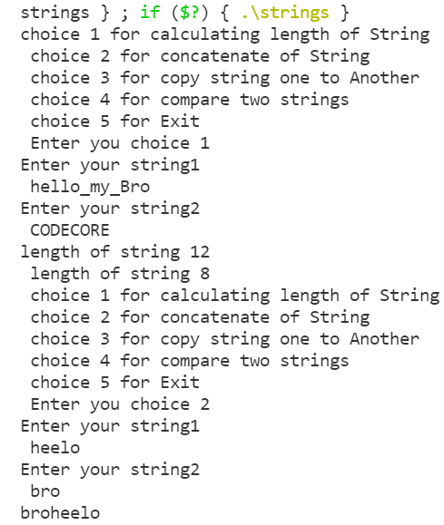 printf("Total characters copied = %d\n", i);

break;

case 6:

exit(0);

break;

default: printf("invalid input.please enter valid input.\n" );

}}

while(choice!=6); return 0; }

**Program 47: Write a program to find factorial using recursion.**

**Source Code:**

#include<stdio.h>

#include<conio.h>

long int multiplyno(int n);

int main(){

int n; printf("enter a positive integer: "); scanf("%d",&n);

printf("factorial of %d=%d",n,multiplyno(n));

return 0; }

long int multiplyno(int n){

if(n>=1)

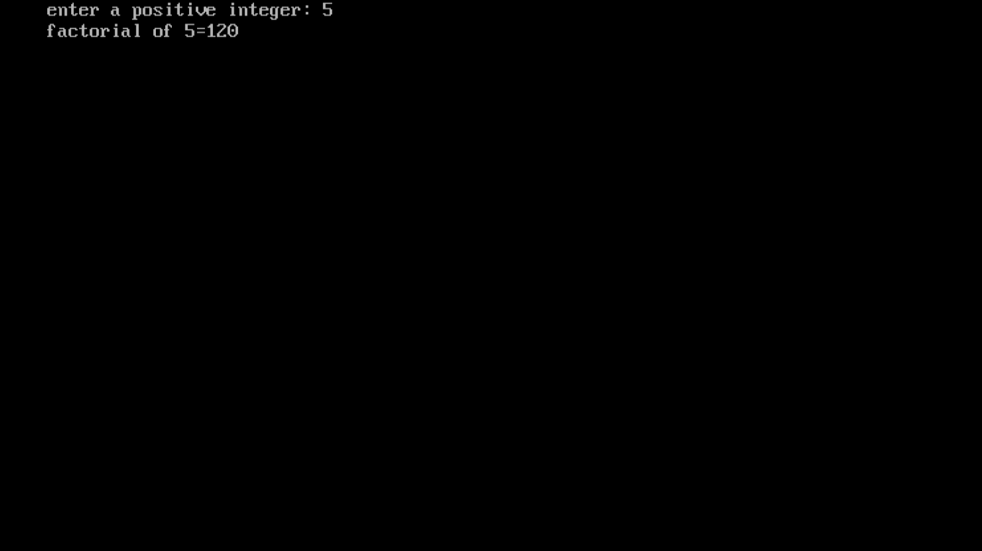return n*multiplyno(n-1);

else

return 1;

}

**Program 48: Write a program to convert hexadecimal into binary number.**

**Source code:**

#include <stdio.h>

#include <string.h>

int main()

{

char hex[17], bin[65] = "";

int i = 0;

printf("Enter any hexadecimal number: ");

gets(hex);

for(i=0; hex[i]!='\0'; i++)

{

switch(hex[i])

{

case '0':

strcat(bin, "0000");

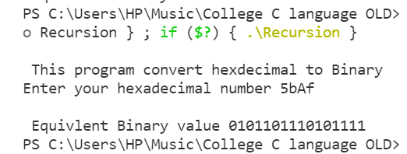 break;

case '1':

strcat(bin, "0001");

break;

case '2':

strcat(bin, "0010");

break;

case '3':

strcat(bin, "0011");

break;

case '4':

strcat(bin, "0100");

break;

case '5':

strcat(bin, "0101");

break;

case '6':

strcat(bin, "0110");

break;

case '7':

strcat(bin, "0111");

break;

case '8': strcat(bin, "1000"); break;

case '9': strcat(bin, "1001"); break;

case 'a':case 'A': strcat(bin, "1010");

break;

case 'b':case 'B':

strcat(bin, "1011");

break;

case 'c': case 'C':

strcat(bin, "1100");

break;

case 'd':case 'D':

strcat(bin, "1101");

break;

case 'e':case 'E':

strcat(bin, "1110");

break;

case 'f':

case 'F':

strcat(bin, "1111");

break;

default:

printf("Invalid hexadecimal input.");

}

}

printf("Hexademial number = %s\n", hex);

printf("Binary number = %s", bin);

return 0;

}

**Program 49:** **Write a program to create a structure for students containing the following data members :-**

* **Name of the student**
* **Roll number of the student**
* **Marks of the student**

**Input data of students & display the details of the employee i’d given by the user.**

**Source code:**

#include<stdio.h>

#include<conio.h>

#include<stdlib.h>

struct std {char name[20];

int rollno;

int age;

};

void main()

{

struct std s[10];

int i,n;

clrscr();

for(i=0;i<10;i++)

{

printf("enter the details of students");

printf("\n roll no of student");

scanf("%d",s[i].rollno);

printf("\n enter name of student");

scanf("%s",&s[i].name);

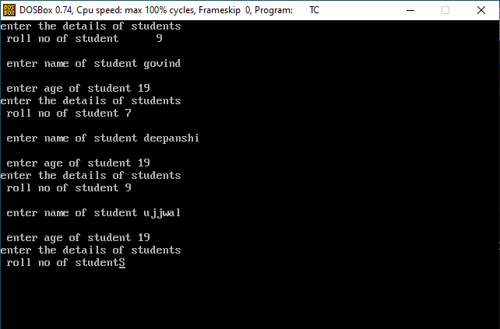printf("\n enter age of student");

scanf("%d",s[i].age);

}

for(i=0;i<10;i++)

{printf("\n name:%s",s[i].name);

printf("\n age :%d",s[i].age);

printf("\n rollno:%d",s[i].rollno);

}getch();}

**Program 50:** **Write a program to pass address of a struct variable to a user defined function and display the content.**

**Source code:**

#include<stdio.h>

struct book

{

    char name[50];

    char Author[40];

    int Pages;

};

void display(struct book *ba);

int main(){

    struct book b1 = {"Shehbaz","code_Power_Harry",10};

    display(&b1);

    printf("size of b1 is %d",sizeof(b1));

printf("size of b1 is %d\n",sizeof(b1.name));

    printf("size of b1 is %d\n",sizeof(b1.Author));

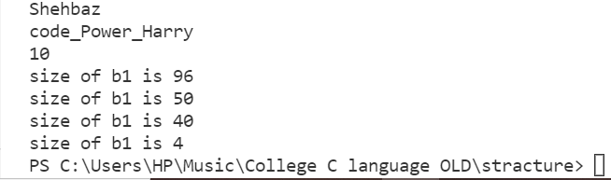    printf("size of b1 is %d\n",sizeof(b1.Pages));

    return 0;

}

void display(struct book *ba ){

    printf("%s\n",ba->name);

    printf("%s \n",ba->Author);

    printf("%d \n",ba->Pages);

}

**Program 51:** **Write a program to make use of array with array in following way:**

* **Use array as a structure data member.**
* **Create array of structure variable.**

**Source code:** #include<stdio.h>

struct student

{char name[100];

    int Age,ID; };

int main(){

    struct student stu[3];

    for (int i = 0; i <3; i++)

    {

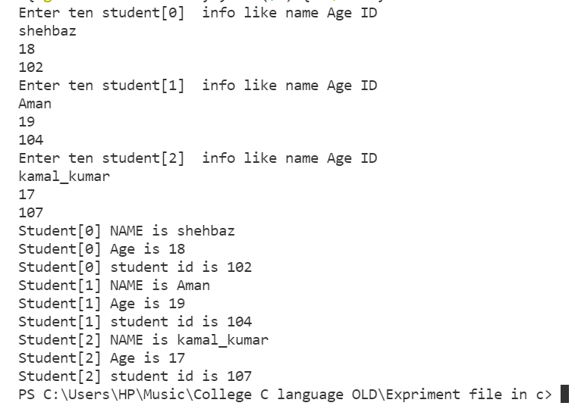    printf("Enter three student[%d]  info like name Age ID \n",i);

        scanf("%s%d%d",stu[i].name,&stu[i].Age,&stu[i].ID);

    }

    for (int i = 0; i <3; i++)

    {

        printf("Student[%d] NAME is %s \n",i,stu[i].name);

        printf("Student[%d] Age is %d \n",i,stu[i].Age);

        printf("Student[%d] student id is %d \n",i,stu[i].ID); }

    return 0;}

**Program 53:** **Write a program in c to show the use of concept of enumeration.**

**Source code:**

#include<ctype.h>

#include<stdio.h>

#include<conio.h>

int main(){

char ch;

int f;

enum etype{

letter, digit, other

};

printf("\n Enter any character: ");

ch=getch();

f=isalpha(ch);

if(f!=0){

printf("%c is type %d symbol",ch,letter);

}

else{

f=isdigit(ch);

if (f!=0){

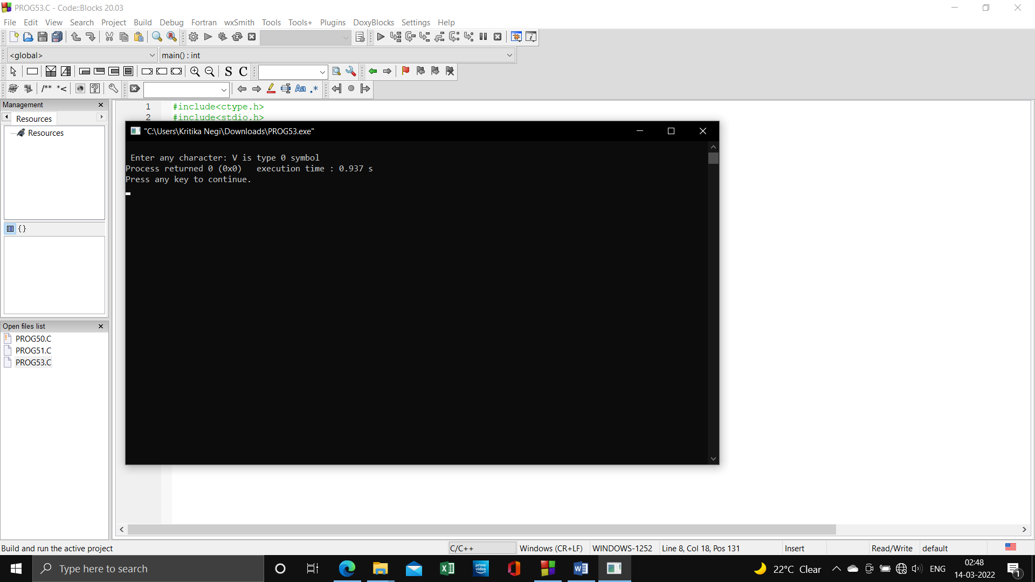 printf("\n%c is type %d symbol",ch,digit);

}

else{

printf("\n%c is type %d symbol",ch,other);

}

}

}

**Program 54:** **Write a program to read the data from the keyboard, write into the file named ‘input’ and again read the same data from the ‘input’ file and display it on the screen.**

**Source code:**

#include<stdio.h>

#include<conio.h>

#include<process.h>

int main()

{

FILE *fp;

char ch;

fp = fopen("input.txt","w");

if(fp==NULL)

{

printf("Can not open file");

exit(1);

}

printf("Write data & to stop press .");

while(ch!='.')

{

ch =getche();

putc(ch,fp);

}

fclose(fp);

printf("\nContent read");

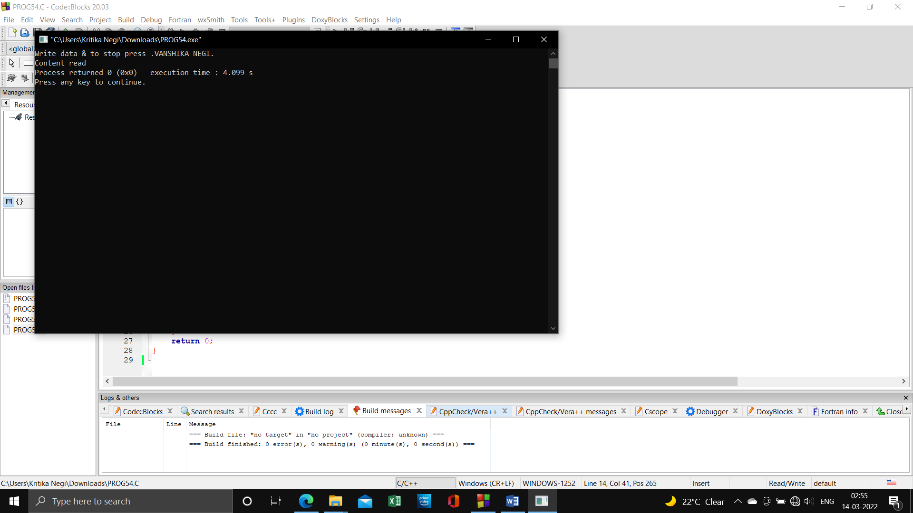 fp=fopen("Input.txt","r");

while(feof(fp))

printf("%c",getc(fp));

return 0;}

**Program 55:** **Write a program to read the data from the keyboard, write into the file named ‘input’ and again read the same data from the ‘input’ file and display it on the screen.**

**Source code:**

#include <stdio.h>

#include <stdlib.h>

void main()

{

FILE *fptr;

char fname[20];

char str;

printf("\n\n Read an existing file :\n");

printf("------------------------------\n");

printf(" Input the filename to be opened : ");

scanf("%s",fname);

fptr = fopen (fname, "r");

if (fptr == NULL)

{

printf(" File does not exist or cannot be opened.\n");

exit(0);

}

printf("\n The content of the file %s is :\n",fname);

str = fgetc(fptr);

while (str != EOF)

{

printf ("%c", str);

str = fgetc(fptr);

}

fclose(fptr);

printf("\n\n");

}

**Program 56:** **Write a program to show the use of W+ mode in file handling. Source code:** #include<stdio.h>

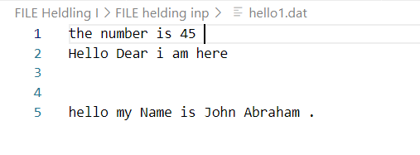#include<conio.h>

#include<process.h>

void main(){

    FILE *fptr;

    char ch;

    printf("content of File before  Appending \n ");

    fptr=fopen("hello1.dat","r");

    while (!feof(fptr))

    { ch= getc(fptr); }

    printf("%c",ch);

    fclose(fptr);

    printf("you want to Stop file writing press (.) \n");

    fptr=fopen("hello1.dat","a");

    while (ch!='.')

    {

        ch= getche();  //getche use to take character from user

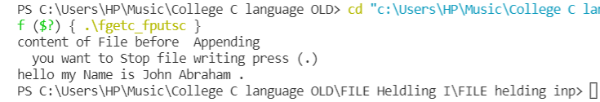        putc(ch,fptr); //puts use to dump content in file

    }

    fclose(fptr); getch(); }

**Program 57:** **Write a program to open a file for read or write operation in binary mode read and write a new information in the file.**

**Source code:** #include<stdio.h>

#include<conio.h>

#include<process.h>

void main()

{

    FILE *fp;

    char ch;

    fp=fopen("INPUT.txt","a+");

    if(fp==NULL){ printf("Can't open file"); }

    printf("Write data and to stop press(.) \n ");

    while(ch!='.')

    {

        ch=getche();

        putc(ch,fp);

    }

    rewind(fp);

    while(!feof(fp)){

        ch=getc(fp);

        printf("%c",ch);

    }

    fclose(fp); }

**Program 58:** **Write a program to open a text file and write some text using fprintf().**

**Source code:** #include<stdio.h>

int main(){

    FILE *ptr;

    char text[30];

    int age;

    ptr = fopen("hello.txt","w");

    printf("Enter text in your File ");

    gets(text);

    fprintf(ptr,"%s",text);

    fclose(ptr);

    ptr = fopen("hello.txt","r");

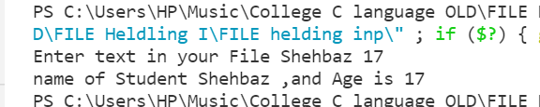    fscanf(ptr,"%s%d",text,&age);

    printf("name of Student %s ,and Age is %d \n",text,age);

    fclose(ptr);

    return 0;

}

**Program 59:** **Write a program to create a file “data” which contains a series of integer numbers and then write all the odd numbers to a file called “odd file” and all the even number in “even file”.**

**Source code:**

#include <stdio.h>

#include <conio.h>

#include <process.h>

void main() {

    FILE *f1, *f2, *f3;

    int number, i;

    printf("Contents of DATA file\n\n");

    f1 = fopen("Data.txt", "w");

    for (i = 1; i <= 30; i++)

    {

        scanf("%d", &number);

        if (number == -1) //-1 use for break loop; for exit

            break;

        putw(number, f1);}

    fclose(f1);

    f1 = fopen("Data.txt", "r");

    f2 = fopen("odd.txt", "w");

    f3 = fopen("even.txt", "w");

    while ((number = getw(f1)) != EOF)

    { if (number %2==0)

            putw(number, f3);  //Write to EVEN file

        else

            putw(number, f2);  //Write to ODD file

    }

    fclose(f1);

    fclose(f2);

    fclose(f3); //we go to read file on console

    f2 = fopen("odd.txt", "r");

    f3 = fopen("even.txt", "r");

    printf("\n\nContents of ODD file\n\n");

    while ((number=getw(f2))!=EOF)

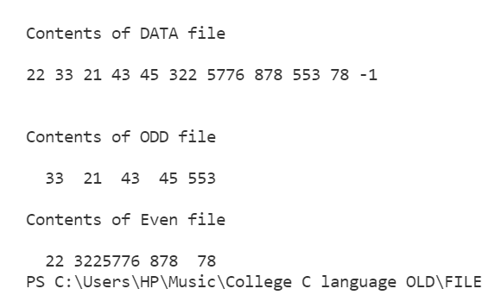        printf("%4d",number); //%4d use for give four Space then number

    printf("\n\nContents of Even file\n\n");

    while ((number=getw(f3))!=EOF)

        printf("%4d",number);

     fclose(f2);

     fclose(f3); }

**Program 60:** **Write a program to read the text file containing some sentence use fseek() and read the text after skippping n characters form beginning of the file.**

**Source code:**

#include<stdio.h>

void main(){

    FILE *fp;

    int n; char ch;

    fp=fopen("Text.txt","w");

    while (ch!='.'){

        ch= getchar();

        putc(ch,fp);

    }

    fclose(fp);

    fp=fopen("Text.txt","r");

    printf("\n content of the file \n");

    while ((ch=fgetc(fp))!=EOF){

        printf("%c",ch);

    }

    fclose(fp);

    fp=fopen("Text.txt","r");

    printf("How many character you want to Skip \n");

    scanf("%d",&n);

    fseek(fp,n,SEEK_SET);

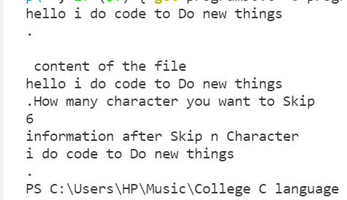    printf("information after Skip n Character \n");

    while((ch=getc(fp))!=EOF){

        printf("%c",ch);

    }

    fclose(fp);

}